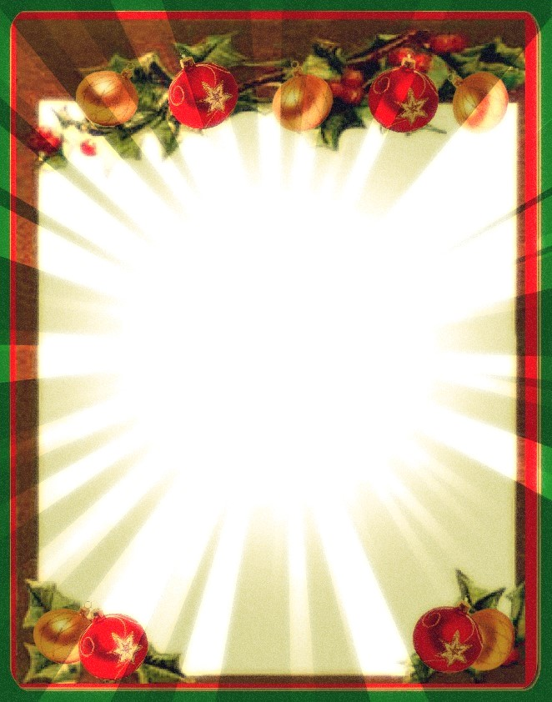

**FORTHCOM ING EVENTS THIS DECEMBER**

**Sunday 9th December 2.00pm**

**Community Carol Service**

Join us for a fun, informal carol singing event,

featuring Hornsmill Primary School. Led by Rev David Bintliff and followed by refreshments.

**Monday 17th December 6.30pm-7.00pm**

**Carol Singing at Tesco**

**Sunday 23rd December 10.30am Carol Service**

Followed by refreshments including mince pies

**Monday 24th December Christmas Eve 4.00pm Christingle Service**

The story of the first Christmas – with sweets, candles and oranges!

Followed by drinks and mince pies.

**Tuesday 25th December Christmas Day 10.00am**

Christmas Family Celebration

at The Hurst, Kingsley