The history of Helsby Methodist Church

John Dearden

Beginnings of Methodism locally

Methodism in Cheshire appears to have developed in the first instance through the ministry of a man called John Bennets (1714-1759). Apart from introducing Methodism to Cheshire, his chief claim to fame is that he married the lady to whom John Wesley thought himself engaged. By 1800 there were 18 Methodist chapels in Cheshire.

John Wesley (1703-1791) was the founder, with his brother Charles, of Methodism. He travelled far and wide, and preached both indoors and out-of-doors to many thousands of people. For example, on Sunday 13 April 1788 in Manchester he recorded in his Journal (now available online: https://onlinechristianlibrary.com/book/the-journal-of-john-wesley): ‘Mr. Simpson assisting. we dealt very well with a crowded congregation. I suppose we had about a thousand communicants…’ On the following day, ‘At noon I preached at Northwich to such a congregation as scarce ever was seen there before…In the evening I preached to the affectionate congregation at Chester…’

John Wesley’s first visit to Cheshire was in 1745, when he preached at Shrigley Fold, near Macclesfield, and his first visit to Chester was in 1752. He preached at a Meeting House in Preston-on-the-Hill in 1781 and 1783. Wesley is said to have once stayed overnight at New Pale Lodge, Manley (see Figure 3 and accompanying text). His preaching inspired other itinerant preachers, and in 1773 ‘the Methodist preachers first visited Frodsham. Sometimes preaching in the open air, and at other times in a cottage’ (Slater, 1891). N.B. Full book and article references are given in the Bibliography at the end of this chronicle.

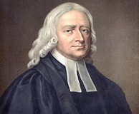
The above leads one to wonder if John Wesley ever came to Helsby, although there is no mention of Helsby in his Journal. However, he does mention Frodsham; on 16th April 1788 he wrote: ‘Prayed, Psa.1, 23 tea; 6.15 chaise; 8 Frods[ham], tea; 8.45 chaise…’ There is a similar entry for 7th April 1790: ‘Prayed, tea; 5 chaise; 7 Frods[h]am, tea; 8 War[ring]ton, writ Essay…’

Figure 1. Rev. John Wesley

Kingsley Methodist Church website (www.kingsleymethodist.org.uk/about_us.htm#history) states that John Wesley ‘frequently passed through Frodsham on his way between Chester and Warrington’. That would seem to make it almost certain that he also passed through Helsby.

Concerning John Wesley, Slater (1891) commented: ‘John Wesley said that “Methodism was raised up to reform the Church”. There are hundreds of instances in which these words have been visibly verified. There is no doubt that the Church was asleep, and would probably have so remained to this day, had it not been for the fact that the non-Episcopalians were everywhere hoisting their standard in the hundreds of neglected villages, which practically were extra-parochial, and belonged to “no-man’s land”’.

An ancestral relation of a present member of Helsby Methodist Church (HMC) received a letter from John Wesley; it is reproduced here:

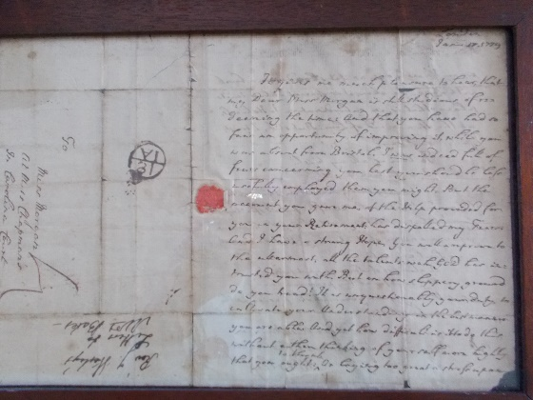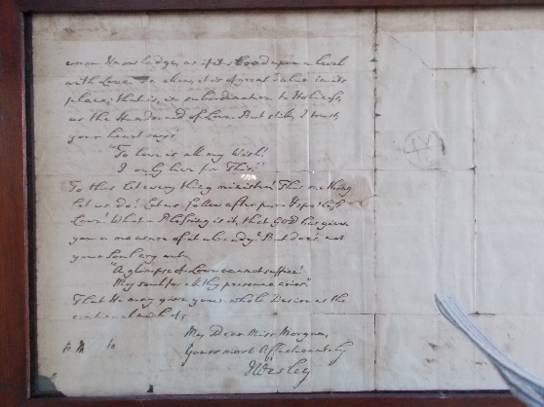

Figs. 2a and 2b. Letter from Rev. John Wesley to Miss Morgan, dated 17 January 1789

The growth of Methodism in Frodsham and environs

Those visits by John Wesley undoubtedly stirred local people, for a number of small ‘Societies’ were set up, which met in homes or barns for prayer and praise. ‘Some time in the year 1790, the Methodists fitted up two bays of a barn for preaching in the town of Frodsham, which were given to them by a farmer for that purpose. This place they occupied for the space of 12 or 14 years, until Divine Providence gave them the means of erecting a substantial chapel at the east end of the town, which has, since its erection, been considerably enlarged, so that it is now capable of accommodating 5 or 600 persons. With this chapel has been connected, for many years, a good Sunday school’ (Janion, 1833).That ‘substantial chapel’ was in Fluin Lane (formerly called Chapel Lane), and is now occupied by Kingsley Carpets.

Frodsham (and presumably its environs) was originally placed in the Northwich Circuit, which was formed in 1792. However, Bretherton (1903) lists Helsby as being in the Chester Circuit in 1817. In 1848 Frodsham was placed in the new Runcorn Circuit, and in 1872, mainly at the instigation of Thomas Hazlehurst of Runcorn (see later), Frodsham became a separate Circuit (Methodist Recorder, 25 October 1906), until it joined with the Kelsall Circuit in 1992 to form the Delamere Forest Circuit, which itself merged with the Chester Circuit in 2012 to become the Chester & Delamere Forest Circuit. More recently still, in 2019, the Runcorn Circuit was incorporated, and the whole became the North Cheshire Circuit.

A Methodist chapel was erected in Norley in 1779, another in Kingsley in 1788/9 (replaced by The Hurst in 1871), one in Mouldsworth in 1815, one in Blake Lees in 1843, one on The Rock, Frodsham in 1837, one (Primitive Methodist) in Manley in 1859, and another, Eden Chapel in Bradley Lane, Frodsham, in 1858. Trinity Church, Frodsham was built in 1873, and Five Crosses Wesleyan Church, Frodsham was built in 1885. A Blue Plaque on the wall of the former church on The Rock, Frodsham, reads: ‘Built in 1837, for one hundred years this building was the Wesleyan Association (Tabernacle) Chapel. After the (second World) war it became the public library’. It has now been converted into flats.

The Primitive Methodist movement (nicknamed ‘The Ranters’), which was founded by, among others, Hugh Bourne (1772-1852), started around the Cheshire-Staffordshire border in or about 1807. They later became active in Frodsham, especially near Frodsham Bridge. A house in the terrace on the main road became their chapel; it used to display a plaque, but that has now been removed. In 1878 the Primitives moved to another main road location close to the railway bridge, which was called Bourne Primitive Methodist Chapel until 1932, when Wesleyan, United and Primitive Methodists merged to become the Methodist Church. Bourne closed in 1987, and was later converted to flats.

Another house where people met for praise is New Pale Lodge, off New Pale Road in Manley, believed to have been occupied in the 1790s by George and Alice Pugh (see The Cheshire Sheaf, January 1939, pp. 4 ff). Janion (1833) wrote of it: ‘When I call to mind the public meetings that were held at the New Pale about forty years ago (i.e. about 1793), especially our love-feasts, which came round once or twice in the year, I think I am got back to the primitive ages of Christianity, when simplicity and godly sincerity occupied every bosom. We were of one heart and one soul, and only love inspired the whole. The influence of these love-feasts spread as far as Manchester and Bolton, and our friends came from every quarter. Such crowds came from the neighbouring villages, that we were obliged at times to hold the love-feasts out of doors, or in some of the out-buildings; and great were our rejoicings on those occasions. Mrs. Pugh had not attained her 60th year when she exchanged mortality for life’.

Latham (1991) states that: ‘According to the historian Pamela Horn, their prayers would mount into a frenzy at these love feasts with men and women clasping each one another, crying out and throwing themselves on the floor in a kind of ecstasy’. Latham also mentions love-feasts held in Delamere Forest, and comments that ‘it was not unusual in the midst of the praying and conversation for persons to pass into a state of trance and have visions; hence the name, the Magic Methodists’. There is nothing to indicate that this nickname suggested the use of ‘magic mushrooms’ which are hallucinogenic.

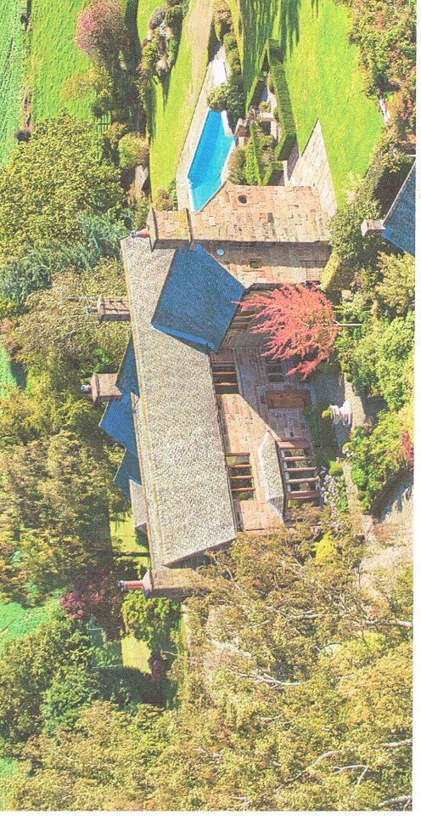

Fig. 3. New Pale Lodge (photograph taken from estate agent’s 2020 brochure)

A sales brochure for New Pale Lodge in 2020 stated: ‘The original property which dates from 1623 is believed to have been built as a Royal Hunting Lodge and in the 18th Century John Wesley is reputed to have stayed (there) prior to embarking on his trip to Ireland…In recent years the current owners have completely renovated and extended New Pale Lodge…There is a sandstone lintel bearing the initials GP and dated 1667’. GP could be George Pugh. Bretherton (1903) listed the names of those who were members at the New Pale in 1790: ‘Ralph Rolinson, Ann Rolinson, George Pugh, Alice Pugh, Robert Pugh, Esther Pugh, Margery Dych, Mary Tickle, Ann Hall, Martha Othwell, Martha Capper, Martha Mercer, William Parkinson, Martha Parkinson. The number of members was 17 in 1803.

A few hundred yards further down New Pale Road is New Pale Farm. Rev. Eric Challoner, a Methodist minister, wrote in a book that is effectively his autobiography (Challoner, 1998) some words written by George Slater (1891): ‘At that time the New Pale, a large farm on the borders of Delamere Forest, was honoured by it being the residence of Mr George Pugh…he was not only a Christian man, but it is said that he did more than his predecessors to reclaim and cultivate that large farm. Challoner goes on to say: ‘Mr. George Pugh…opened his house for religious services and it appears that these continued for several years. It was a great centre and it was common for devoted men from many parts of the country and even from Manchester to attend Love Feasts and Revival services at the New Pale. A Love Feast was a simple service, in some ways similar to Holy Communion. This all happened in what became our dining room at the New Pale and I never knew about it until reading Slater’s Chronicles’. Challoner lived at New Pale Farm for several years as a boy.

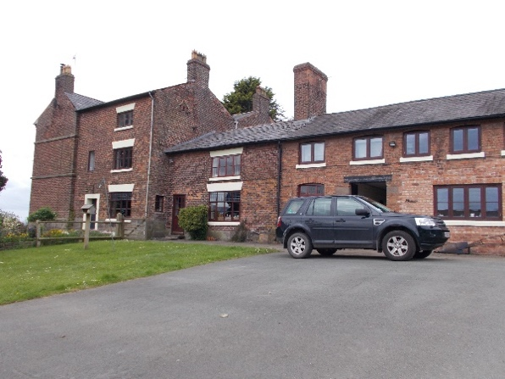
The room where the meetings were claimed to be held is on the ground floor of the three-storey part of the house.

However, there is no historical evidence that New Pale Farmhouse was the location for Methodist services and love-feasts. It is known that New Pale Farmhouse was occupied by a family called Harrison from 1737 to the 20th century. Slater’s (1891) statement that ‘the New Pale, a large farm…was honoured by being the residence of a Mr. George Pugh’ could be because the house now known as New Pale Lodge could also have been a
Fig.4. New Pale Farmhouse.
large farm. In fact Latham (1991) mentions that: ‘in 1864 the Claim Farm, which included New Pale Lodge, was sold by the Duncufts, the then owners, to John Higson’.

Bretherton (1903) lists the 27 places that were in the Chester Circuit in 1817; they included Helsby and, perhaps surprisingly, *Godscroft, the asterisk indicating that it was supplied with a preacher only fortnightly; 36 preachers were listed. An article in the Chester Chronicle for 12 July 1873 recorded that ‘When Methodist circuits embraced a much wider range of country than they do now, and when the facilities for travelling were much less…walking twenty or thirty miles and preaching two or three times on a Sabbath was quite a common thing for Methodist preachers to do formerly.’

The growth of Methodism in Helsby and environs

So far as is known, the first Methodist Society involving Helsby people was at Godscroft (God’s Croft?) Hall in Godscroft Lane in 1799, when there were six members. By 1803 there were eight members: Arthur Lewis (who lived at Godscroft Hall), Ann Lewis, Samuel Burgess , Hannah Burgess, Joshua Worrall, Phyllis Pugh, Alice Unsworth and Mary Harper. There were 10 members in 1810, 19 in 1822 and 10 in 1831 (Bretherton, 1903). Although Godscroft Hall is just on the Frodsham side of the Helsby-Frodsham boundary, at least some of the Methodists meeting there lived in Helsby.

John Lewis (1722-1775) of Helsby, and formerly of Alvanley, had 11 children, including Thomas (1755-1797) and Arthur (1762-1838). Thomas had a son Thomas (1787-1857), who married Elizabeth Haspell (1774-1852), niece of Samuel Burgess (1776-1844)) in 1815. Elizabeth lived at Rake House, Lower Rake Lane, which was built for her in 1807. They had a son Thomas Haspell Lewis (1815-1880), who also later lived at Rake House. He was a member of the Methodist Free Church with his great-uncle Samuel Burgess (1776-1844) (see below). His son by his second wife Jane Slater (sister of George Slater), Joseph Slater Lewis (1852-1901), was the first managing director of Britannia Telegraph Works, which was a forerunner of the BICC (British Insulated Callender’s Cables).

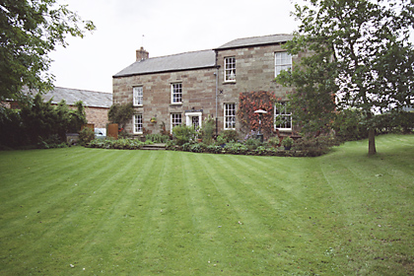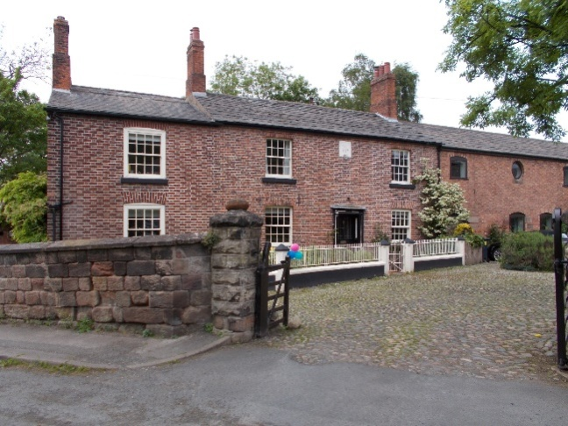

Fig. 5. Godscroft Hall Fig. 6. Rake House. The plaque on the wall reads: EH 1807

It is believed that worship services were also held at Youds Cottage (7 Old Chester Road, Helsby), some time in the 19th century.

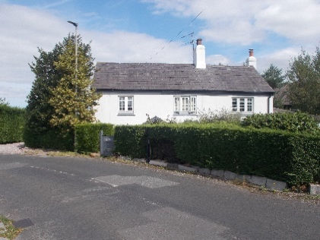
Samuel Burgess (1776-1844) lived at Undermount, Chester Road, Helsby, which was built in 1765, and in 1800 he ‘fitted up a large room on his own premises, with a view of affording accommodation to his family and neighbours therein, to worship God and to hear His word. He likewise established a Sunday-school, in which 100 children receive gratuitous
instruction, every Lord’s day. This is, probably, one of the best conducted Sunday-schools in this part of the county’ (Janion, 1833). The ‘large room’ is believed to be on the first floor, and may have been accessed via the stone
Fig. 7. Youds Cottage
steps at the rear of the house, although an article in the Helsby Women’s Institute booklet “Helsby Heritage” (2007) states that access was internal. It may be that Mr. Burgess converted a barn for the purpose of worship, and the photograph (Fig. 8) of Undermount shows what looks like a former barn entrance.

Fig. 8. Undermount, Chester Road
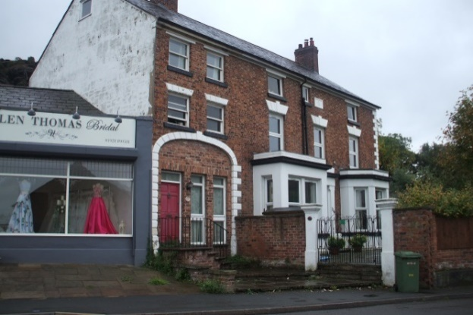
The plaque on the wall reads: BSE 1765
(Burgess, Samuel [&] Ellen)
Slater commented that ‘Mr. Burgess at this time (1837) was vigorously engaged in his good work. He was practically the bishop of the whole place’. He also started a Children’s Sick Club in 1836, which paid out when children were ill and when they died. The Chester Chronicle reported on 22 December
1917 that the Sick Club was divided (wound up) on 21 December 1917. Morris (2016) wrote: ‘During the 19th century it was common practice for families to enrol their children in a “burial club” for a halfpenny a week. If the child died the club would pay out as much as £5 towards funeral expenses. Since a cheap funeral would cost around £1 this would leave a considerable surplus for feeding and clothing the remaining children. Unfortunately this meant that the appeal of life insurance payouts became a potent cause of infanticide.’

In 1835 came the great schism in Methodism. Slater (1891) commented: ‘After the (Methodist) Conference of 1834 there was great agitation among the Methodist people as to some alleged new things that had been introduced into the body, and as to some alleged laws and usages being superseded’. Slater had very hard words to say about Rev. Samuel Sugden, the then Superintendent of the Northwich Circuit, which at the time included Frodsham: ‘He was a man upon whose physical structure and mental calibre nature had not been very lavish; or to speak plainly, he was some degrees below mediocrity in every respect…He was altogether a very common uncultured man of very little education, and was wonderfully inflated with a sense of his own importance’. Early in 1835 Rev. Sugden arbitrarily suspended all Frodsham local preachers over some alleged minor infringement. He then held court in Frodsham against the local preachers. One of them, a Mr. Clarke, ‘quoted some passage of scripture, when Mr. Sugden replied, “I have nothing to do with the Bible”. “What”, said Mr. Clarke, laying his hand on the Bible, “have you nothing to do with this blessed book?” “No”, said Mr. Sugden, “it is Methodism that I have to do with”….The result of all this was that nearly all the preachers and best men of the place were cut off at a stroke…The few cases which I have given are not a twentieth part of the expulsions which took place during Mr. Sugden’s reign. In many cases entire classes were practically expelled wholesale without any sort of trial whatever’.

The effect of the schism in Helsby meant that many Methodists joined the secession or were expelled; it is not clear which. Slater recorded that: ‘In the year 1835 the division took place, and Mr. Burgess and almost the entire society and congregation joined the seceders, now known as the Methodist Free Church’. Slater also called the secession ‘the Reform movement’.

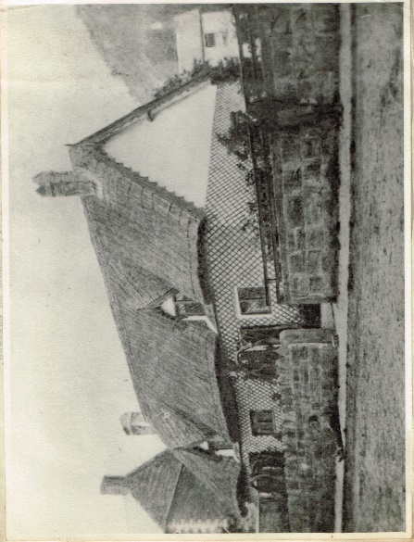
Slater first visited Helsby in 1837. He commented: ‘At that time Helsby appeared to me almost like some foreign country, and though the public turnpike road leads through the village, the whole place appeared to be in a very rough and neglected condition. Farms were practically open to the highroad, which was lined on both sides with all sorts of broken implements, old timber, heaps of manure, and in fact nearly all sorts of refuse seemed to be laid on the sides of the road for the special delectation of passers-by’. On the other hand, he says later that ‘I found Helsby to be very charming in some respects, beautifully situated, and a very genial climate…It is a large and populous village and township, in the parish of Frodsham, and had given ample temporal support to the parish church, and yet they had received nothing in return. No school, no church, no service, no religious instruction, and no clergyman had ever lifted his finger, or taken one step to take the bread of life to the famishing people of Helsby’. That, however, is not all true, for he goes on to say: ‘At that time (1837) the Wesleyan chapel in Helsby was a little empty thatched cottage, close to the road, and one of the meanest little buildings in Helsby’.

That mean little building could have been that shown in the photograph, taken from the Women’s Institute scrapbook produced in 1955. Its location can be ascertained from the house in the far left of the photograph, which is Undermount, with distinctive white stone edging on its gable end, and from the hill in the right of the photograph. The location corresponds to where nos. 208-214 Chester Road – a terrace that includes the present (2022) dental surgery – now stand.

Fig. 9. ‘Mean little building’?

The Liverpool Mercury for 6 July 1838 reported the Frodsham celebrations of Queen Victoria’s coronation on 28 June 1838.

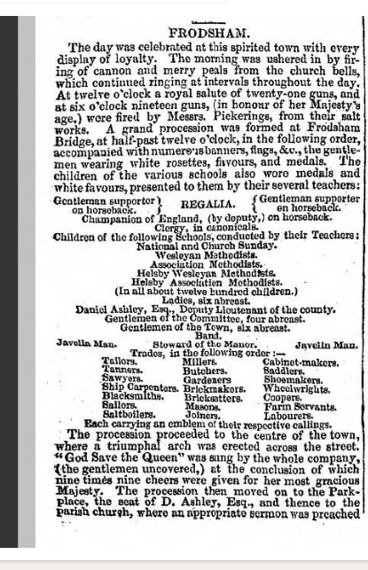
Fig. 10. Frodsham coronation celebrations on 28 June 1838

Despite the fact that no Methodist churches had been built in Helsby by 1838, the newspaper report (Fig. 10) mentions that children from the Schools of Helsby Wesleyan Methodists and Helsby Association Methodists participated in the procession. Presumably Helsby did not have its own celebrations.

More light is thrown on the two Schools by an article in the Runcorn Examiner for 3 July 1880 which described a celebratory procession of over 2000 teachers and scholars of the non-conformist bodies in Frodsham and district. The article mentioned ‘the Wesleyan Methodist School, Helsby, instituted 1815, and having 10 teachers and 80 scholars. Next came the United Methodist Free Church School, Helsby, instituted 1835, and which now has 15 teachers and 134 scholars’. So despite not having official church buildings, Helsby Methodists were going strongly in the first half of the 19th century.

In 1851 an Ecclesiastical Census was carried out as part of the general 1851 census (https://discovery.nationalarchives.gov.uk/details/r/C8993).
Two records are available for Methodist churches in Helsby. In 1851 there were no built Methodist churches in the village, but the census requirement was for any place of worship, including private dwellings. The first record was for a ‘Wesleyan Methodist Chapel…erected, consecrated or licensed’ in 1820; the informant was Samuel Burgess – almost certainly the son of the Samuel Burgess who started a Sunday School in his home, Undermount, in 1800, and who died in 1844; the ‘chapel’ was almost certainly a room in Undermount. Samuel Burgess the younger, together with the Earl of Cholmondeley, also conceived the plan for making a carriage drive round the front of Helsby Hill in the 1860s, to make Helsby a desirable residential area for neighbouring city merchants and professional men. It also provided work for unemployed local men.

The second record was for a ‘Wesleyan Methodist Chapel…erected, consecrated or licensed’ in 1837; the informant was John Hitchin, local minister and steward. Slater (1891) stated: ‘I remember in my early visits to Helsby, I often heard the name of John Hitchen; he was a poor shoemaker, and belonged to the old Methodists. He had the reputation of being one of the best men in Helsby’. (The spelling ‘Hitchin’ in the Ecclesiastical Census record is probably a transcription error.) It may not be a coincidence that the given date (1837) of erection, consecration or licence is the same as the date of George Slater’s first visit to Helsby. As mentioned above, Slater commented: ‘At that time the Wesleyan chapel was a little empty thatched cottage, close to the road, and one of the meanest little buildings in Helsby’. It could be that the thatched cottage was the place of worship mentioned in the Ecclesiastical Census record. The Chester Chronicle for 12 July 1873 reported the death of John Hitchen, saying: ‘For upwards of fifty years he was the principal, and for a great portion of that time the only class leader in the (Helsby) Wesleyan Society’.

Folio 49. Folio 50.
Place of worship: Wesleyan Methodist Chapel. Place of worship: Wesleyan Methodist Chapel.
Parish or place: Helsby, Frodsham. Parish or place. Helsby, Frodsham.
Date erected, consecrated or licensed: 1820. Date erected, consecrated or licensed: 1837.
Religious denomination: Wesleyan Methodist. Religious denomination: Wesleyan Methodist.Informant: Samuel Burgess, manager. Informant: John Hitchin, local minister & steward
Estimated attendance on Sunday 30 March 1851: Estimated attendance on Sunday 30 March 1851:
morning 44, afternoon 54, evening [not stated]. Morning 25, afternoon 59, evening [not stated].

Ecclesiastical Census Records for two Wesleyan Methodist Chapels in Helsby on 30 March 1851

This explains the statement in an 1850 Cheshire Directory (Bagshaw, 1850) that: ‘There are
two Wesleyan Methodist Chapels in Helsby’.

The 1844 tithe maps are available on Cheshire West & Chester Council’s website (www.cheshirewestandchester.gov.uk), and Plot 303 on the tithe map (located where nos. 208-214 Chester Road now stand) comprised two cottages, one of which was occupied or used by John Hitchen. Thus it is almost certain that that is the ‘little empty cottage’ described by Slater (1891) where John Hitchen held worship services prior to Trinity Wesleyan Chapel being built in 1853.

Methodist Churches in Helsby

Trinity Wesleyan Chapel

The first Methodist church to be built in Helsby was Trinity Wesleyan Chapel, located on the main road to the eastern side of Helsby. Its opening was reported by the Liverpool Mercury on 23 December 1853. The church opened on 19 December 1853.

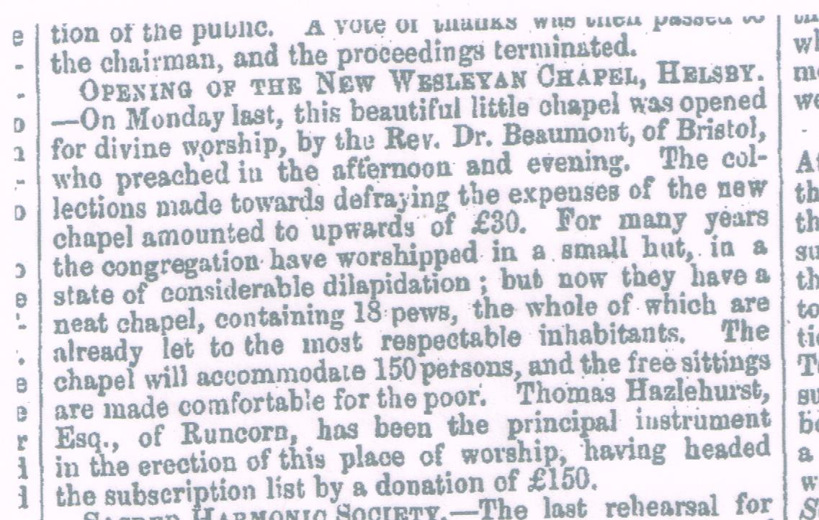
Fig. 11. Report of opening of Helsby (Trinity) Wesleyan Methodist Chapel on 19 December 1853

Nothing is known about the ‘small hut in a state of considerable dilapidation’ mentioned in the Liverpool Mercury article (Fig. 11). It seems unlikely that it was one of the two thatched cottages pictured in Fig. 9 above, which could hardly be described as a ‘small hut’.

It is appropriate here to consider Thomas Hazlehurst. He and his brother Charles owned a soap factory in Runcorn (Morris, 2016). They were devout Methodists, and Thomas in particular made generous financial contributions towards the building of many Methodist churches in the area, including at Frodsham and Kingsley. He was often invited to lay the foundation stone of a new Methodist church, and would always have been presented with a silver trowel with which to perform the symbolic laying of the stone. It is believed that in this way he acquired almost 100 silver trowels, which were displayed at his home. No information is available as to the fate of the collection.

Runcorn Historical Society (www.runcornhistsoc.org.uk) states that ‘Thomas’ death was honoured in the highest place possible in the Methodist Church, at the Methodist Conference of 1878. The following motion was moved by Rev John Rattenbury and seconded by Mr GH Chubb: “That this meeting deems it right to record its sincere regard for the character of the late Mr. Thomas Hazlehurst, of Runcorn, whose services to the cause of God in many ways, and especially in his munificent gifts of chapels, have been of great value, and will confer lasting benefits upon the Connexion, and the Meeting earnestly prays that a similar spirit of Christian zeal may rest upon many survivors.”’

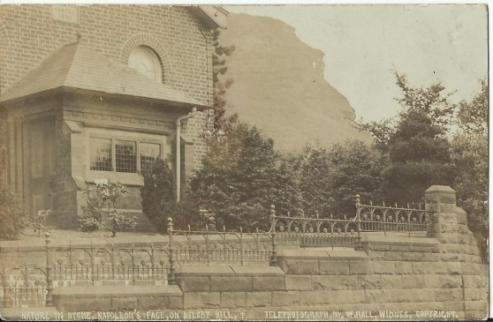
Fig. 12. Helsby Trinity Wesleyan Chapel pictured on a
postcard (date unknown). Note the white cross on the hill.

The plaque above the porch read ‘Wesleyan Chapel 1853’. The word ‘Trinity’ may also have been on the plaque. At some point, perhaps when the building became a private residence, both plaque and porch were removed.
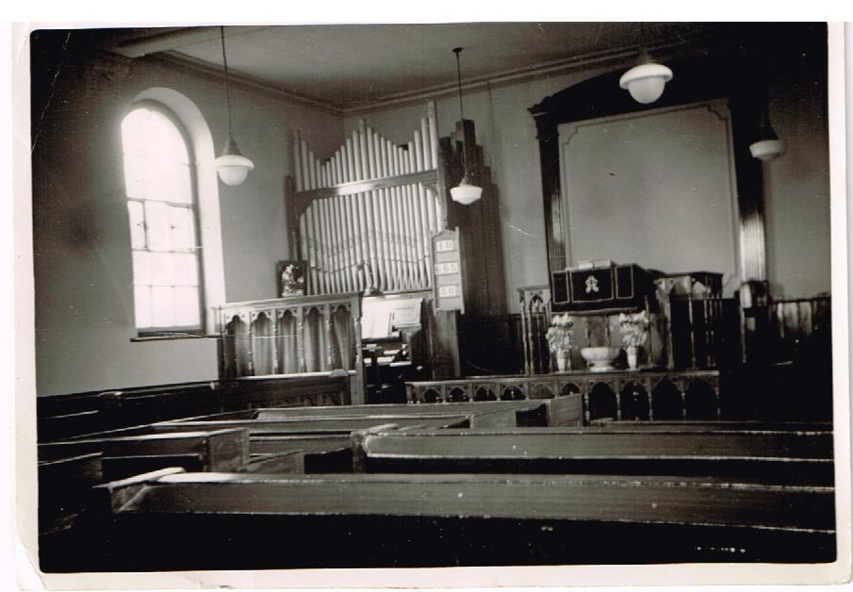
Fig. 13. Interior of Helsby Trinity Wesleyan Chapel (date unknown)

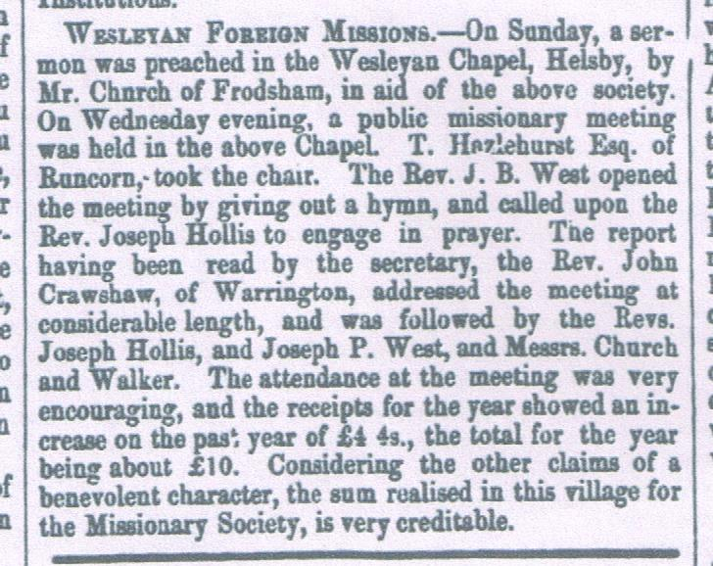
From the beginning, members of Trinity were supporting mission, as an article from the Cheshire Observer for 27 November 1858 shows:

Fig. 14. Report of Trinity mission support

It is interesting to note that Thomas Hazlehurst, who was the principal benefactor in the building of Trinity Chapel in 1853, continued to take an interest in the chapel.

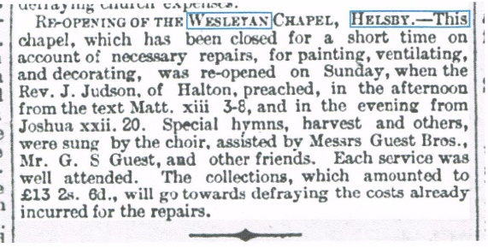
Fig. 15. Report of closure of Trinity in 1888 for repairs.
Trinity was closed for repairs for a short time in 1888, as reported by the Widnes Examiner for 27 October 1888

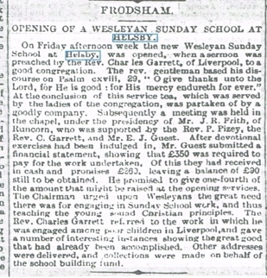

Fig. 16. Report of opening of Trinity Sunday School on 7 October 1892
A Sunday School was built at the rear of the chapel; and opened on 7 October 1892, as the Widnes Examiner reported. The gable of the new Sunday School can just be seen in the 1953 photograph of Trinity (see Fig. 21 below).

Cheshire Records Office, Chester, holds a number of documents relating to Methodism in Helsby. One is an accounts ledger for Trinity. The figures for 1910 make interesting reading.

Income £ s d
Seat rents 1 6 0
Rents of houses, schools & c. 38 5 0
Anniversary, subscriptions, donations, legacies 1 1 0
All other income 8 4 0
Total 48 15 10

Expenditure
Lighting, cleaning, warming 29 5 5
Repairs 2 7 5
Insurance 1 9 9
Organ and choir 2 15 0
Subscriptions to Connexional funds 0 10 0
Circuit Quarter Board 10 0 0
All other expenditure 2 16 0
Total 49 3 7

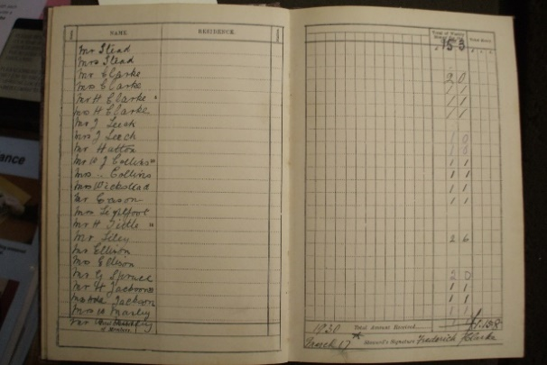
Fig. 17. Q1 1930 collections at Trinity
Cheshire Records Office also holds several other Trinity documents. The photograph below shows collections for the first quarter of 1930 for 23 congregants. It can be seen that the typical contribution was a penny a week, yielding 1s 1d for the quarter.

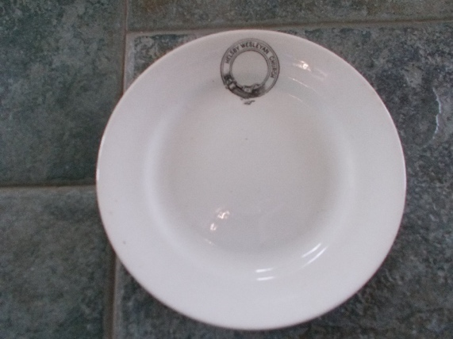
Fig. 18. Small plate inscribed ‘Helsby Wesleyan Church’

Like many churches, Trinity had its own named crockery, as shown in Fig. 18.

.
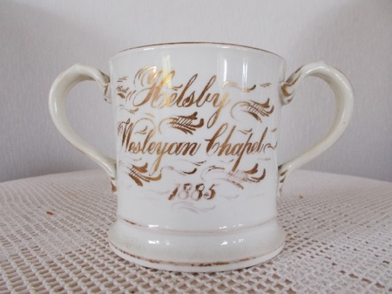
Fig. 19. Trinity loving cup
As well as everyday crockery, Trinity also had two loving cups, typically used at love feasts like those held at the New Pale (Janion, 1833). However, no record could be found of Trinity participating in love feasts. One of the cups is depicted in Fig. 19, with the inscription ‘Helsby Wesleyan Chapel 1885’

Trinity celebrated its centenary in 1953, just five years before it closed.
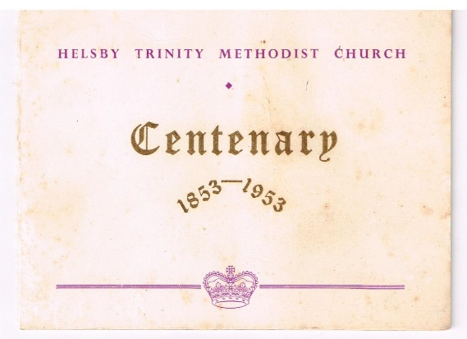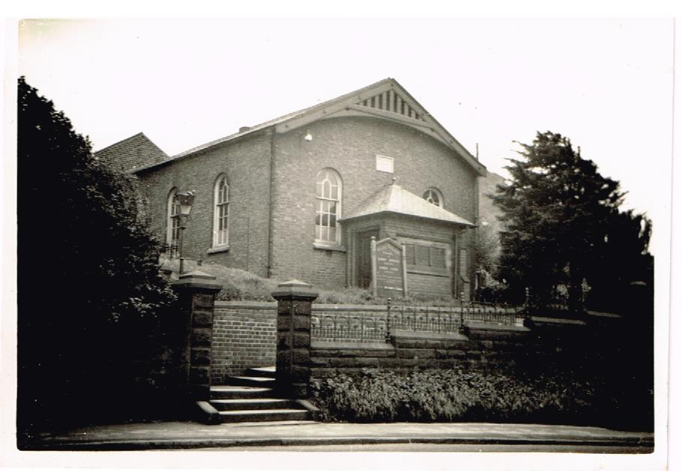

Fig. 20. Trinity centenary celebration Fig. 21. Trinity Wesleyan Methodist Church in 1953
in December 1953

In 1958, as part of the preparation for Helsby Methodist churches to merge (and also, it is understood, because Trinity’s heating failed), Trinity closed and its congregation moved to Helsby United Free Church (Central). It was de-commissioned on 4 February 1960, according to a statutory notice in the Runcorn Weekly News on 11 February 1960: ‘The Registrar General, being satisfied that Trinity Methodist Chapel, Helsby, in the registration district of Runcorn in the County of Chester is no longer use as a place of worship by the congregation on whose behalf it was on 29th October 1892 registered for marriages in accordance with the Marriage Act, 1836, has cancelled the registration’.

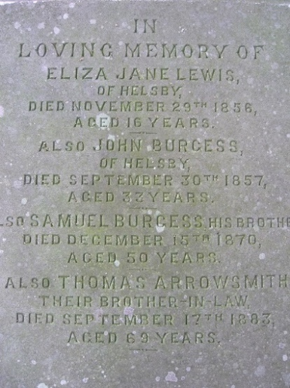
Fig. 22. Gravestone of Samuel Burgess (1820-1870)

The six bodies buried in the small Trinity churchyard had to be disinterred and re-buried elsewhere. The headstones were taken to Central, and are now laid on the grass at the top of the present church car-park. One of them is that of Samuel Burgess the younger, who gave money towards the building of Central in 1858.

Trinity was then used by the Cheshire Education Authority as an infants’ school until about 1967. It then remained empty until 1970, when the Eddisbury Venture Scout Unit obtained planning permission to use it as its headquarters (Runcorn Weekly News 22 October 1970). It is not known for how long the Venture Scouts used the building, but on 18 October 1986 the Runcorn Weekly News reported that the building was then owned by the North West Area Scouts, and that Helsby Parish Council was considering buying the building and leasing it to Helsby Youth Projects for use as a youth club. Vale Royal Borough Council had already approved that plan, but there were 35 objections from people who lived nearby who were concerned about potential noise and vandalism. In the event, the project was abandoned, and the building was eventually sold and converted into a private dwelling.

United Free Methodist Church (Central)
Following secession in 1835, the so-called Association or Free Church Methodists built their own church in 1858. The Chester Chronicle reported its opening.
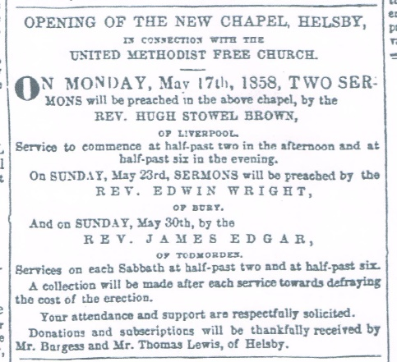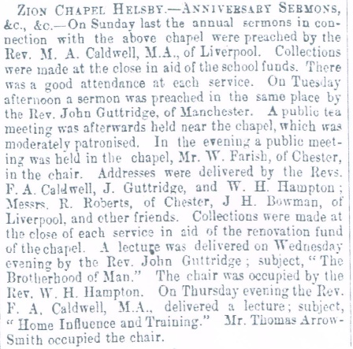
Fig. 23. Opening of Central on 17 May 1858 Fig. 24. Central required renovations in 1872

On 6 July 1872 the Cheshire Observer reported that collections from the anniversary services on 30 June 1872 were in aid of ‘the renovation fund of the chapel’. That was only 14 years after the building was erected!

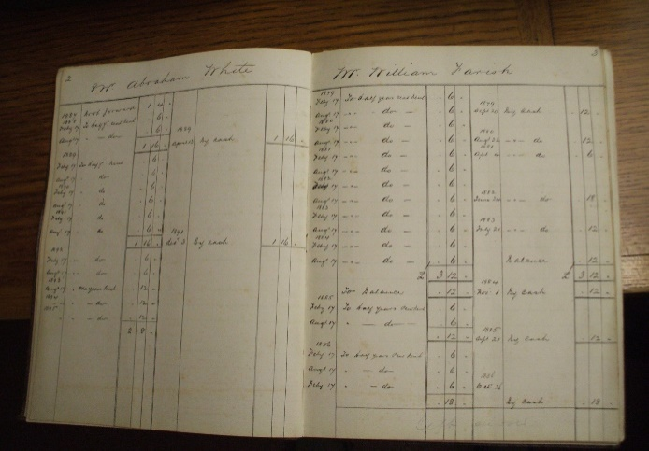
Figure 25. Central pew rental payments by W. Farish for 1879-83
Central followed Trinity in charging pew rentals. For the period 1879-1893 a total of 21 pew rentals were recorded, including one for the Sunday School and one for the Rechabite Club (a temperance organistion). Pew rentals cost 12 shillings a year (equivalent now to about £75). The photograph below shows pew rental payments by Mr. William Farish for the period 1879-1893. William Farish lived at Hillside Villa, at the top of what is now Stephen’s Grove. He was a great temperance advocate, having been a drunkard in his youth, and was mayor of Chester in 1877-78.

By 1896 the church had grown sufficiently to require larger premises, so it was proposed that the 1858 church be demolished and a new larger church built on the site, as reported by the Cheshire Observer for 6 June 1896: ‘The new edifice will consist of a chapel and schoolroom, which may either be used as one hall or divided for the two purposes’.A trustees’ meeting on 15 June 1896 (from Zion Chapel Helsby Trustees’ minutes, held by Cheshire Records Office) sanctioned and passed a resolution to ‘accept a tender to build another chapel and school at a cost of £850’. However, the minutes of the following month’s meeting recorded: ‘Prop. by Mr. Parker and sec.^{d} by Mr. Noden that the tender of Mr. Thos. Davies amounting to £747-5s-0d for new school and alteration and addition to chapel be accepted’. The total cost, including architects’ fees, was estimated to be £1005. From that it appears that the trustees had a change of heart and had decided not to demolish the 1858 church., but instead to alter and extend it. Thos. Davies & Sons were local builders based in Frodsham, as the advertisement in the Frodsham & District Free Church Magazine for June 1901 shows (Fig. 26).

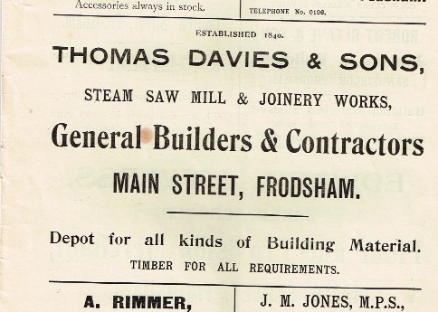
Fig. 26. Thos. Davies & Sons, Builders

An article in the Cheshire Observer for 26 September 1896 confirmed that Messrs. Davies and Son, Frodsham, were the builders of the “new” church, and that the foundations were being laid, so that the Harvest Thanksgiving service was held ‘in a building attached to the residence of Mr. Huntingdon’. Mr. Huntingdon is recorded in the 1891 census as living at ‘Undermount’, which was the house formerly owned by Samuel Burgess the younger, who died in 1870 (see Fig. 22 above, showing the gravestone).

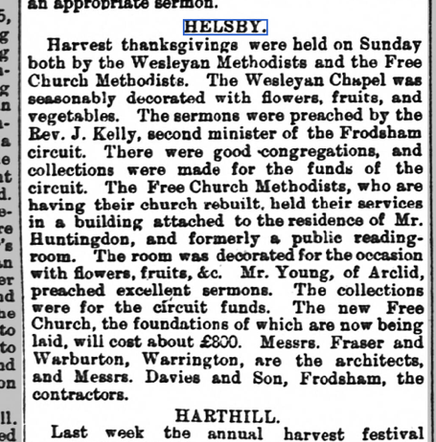
Fig. 27. Helsby Methodist harvest services on 20 September 1896

The Cheshire Observer reported on 21 November 1896 that the object of a concert on 19 November 1896, held in a room belonging to Mr. Huntingdon was ‘to raise funds for defraying the expenses in connection with the erection of their new church’.
On 1 May 1897 the Chester Chronicle reported that a series of services on Wednesday 12 May, Sunday 16 May, Monday 17 May and Sunday 23 May 1897 would be held to celebrate the opening of the new chapel for Helsby United Methodist Free Church. So the first service held in the rebuilt chapel was on 12 May 1897.
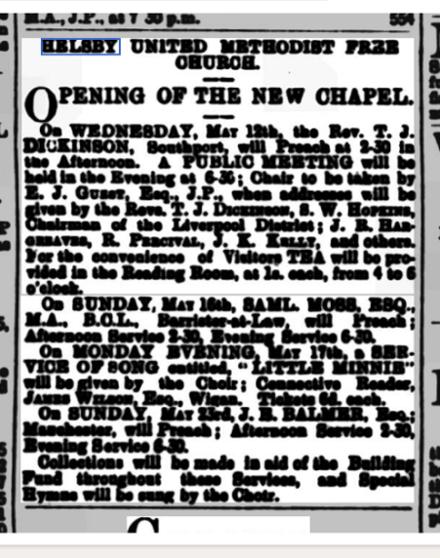
Fig. 28. Report of opening services for the rebuilt
Helsby United Methodist Free Church
A Chester Courant report on 2 June 1897 stated: ‘UNITED METHODIST FREE CHURCH BAZAAR. – A bazaar was held on Wednesday and Thursday (26 & 27 May) in the schoolroom attached to this church, with the object of raising the amount necessary to clear the debt still remaining on the new building’. A Chester Chronicle report on 19 June 1897 stated: ‘On Sunday (13 June) services were conducted, these being the last in connection with the opening…The total receipts to date amount to £773-3s-10d towards the £1000 required’.. A Chester Chronicle report on 4 December 1897 stated that £200 was still required to clear the debt. Fig. 28 shows the church before 1897, because the Sunday school, built in 1897, and visible in the present-day photograph (Fig. 30), is clearly missing.

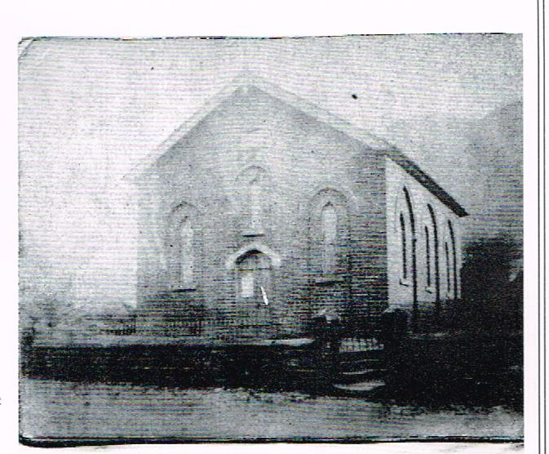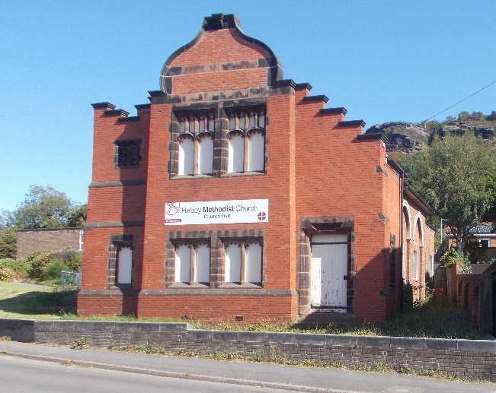

Fig. 29. Central Church before 1897 Fig. 30. Central Church at present (August 2022)
(date unknown)

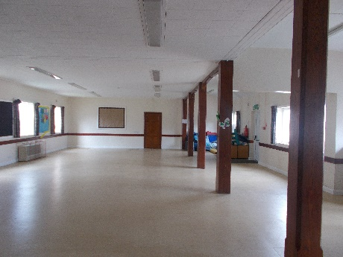
Fig. 31. Present appearance of former church and Sunday School
It is probable that the ‘alteration and addition’ mentioned in the trustees’ minutes for July 1896 included the addition of the organ loft, since there is no further mention of additions in later trustees’ minutes (Zion Chapel Helsby trustees’ minutes; Cheshire Records Office). It is also probable, for the same reason, that the ‘alteration and addition’ included widening the church, requiring pillars to support the original edge of the roof (see Fig. 31 below).

On the pre-1897 photograph of Central a plaque can be seen high up on the gable end. Unfortunately investigation has found that it is no longer there, so presumably it was removed during the 1897 extensions.

The Frodsham & District Free Church Chronicle reported in its April 1901 issue that: “United Mission Services were held in the (Helsby) Free Methodist Church from March 2nd to the 16th, conducted by the local Ministers and others. The congregations on the whole were good and the results cheering, there being several very excellent cases of conversion”. The same magazine also reported that a camp meeting would be held at Helsby in August 1901.

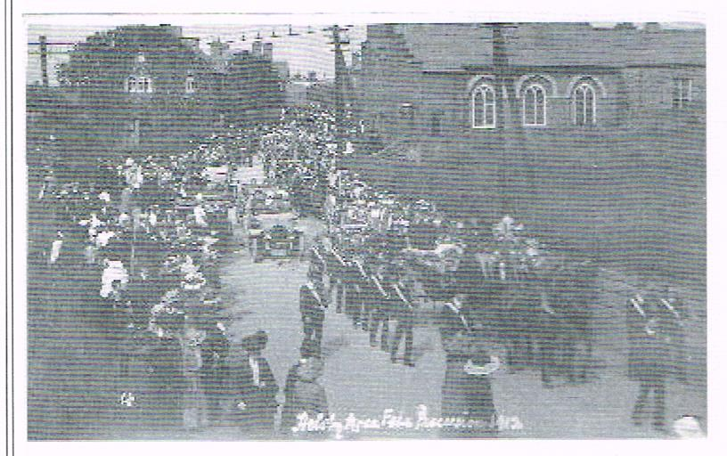
Fig. 32. Central in 1912

The photograph below shows the 1912 Helsby Rose Fête procession passing the church, and the organ loft extension and Sunday school can be clearly seen.

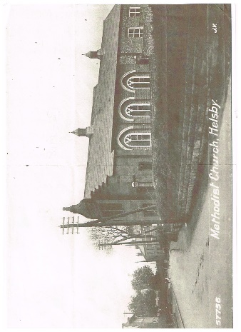

Fig. 33. Central post-1897 and pre-1918
A better photograph, from a post-card, is shown below. It was taken before 1918, because the house adjacent to the church (no. 184 Chester Road), which was built in 1918, was not there.

The trustees’ minutes for 3 December 1913 record that: ‘The meeting saw that Mr. Peter Leach chemist had taken soil away adjoining and in doing so he had in fact taken the soil from under our wall’. That indicates that 184 Chester Road had been a pharmacy from about 1914. In 1925 it was bought by Mr. Edwin Davies, a pharmacist and a church trustee for many years. The pharmacy closed in 1965, when Mr. Davies retired. His wife Elizabeth was the church organist for many years..

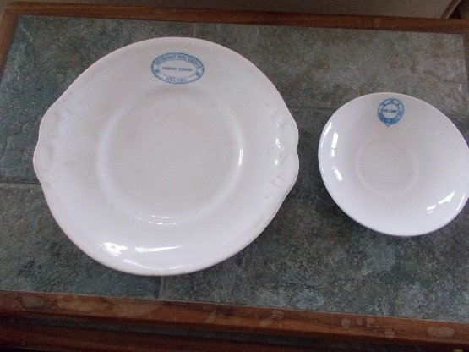
Fig. 34. Examples of Central crockery
Like Trinity, Central had its own named crockery. Fig. 34 shows a large plate bearing the inscription ‘METHODIST FREE CHURCH HELSBY SUNDAY SCHOOL, and a bone china saucer with the inscription U.M.C. HELSBY

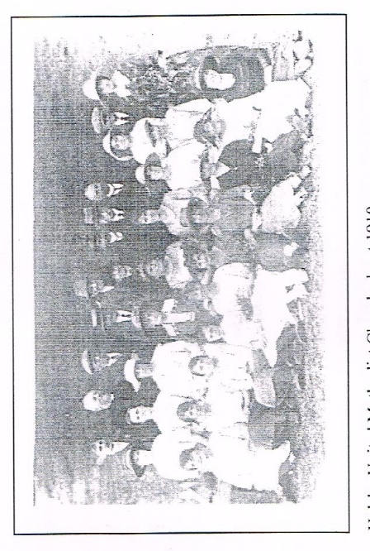
There is virtually no information available about Central and its activities from the early 20th century up to the 1950s, when plans started to be made about merging the three Helsby Methodist churches and building a new church building.

Fig. 35. Central congregation in ca. 1910
Fig. 35 below shows the Central congregation in about 1910. There are 29 people plus the minister, Rev. Slack.

.

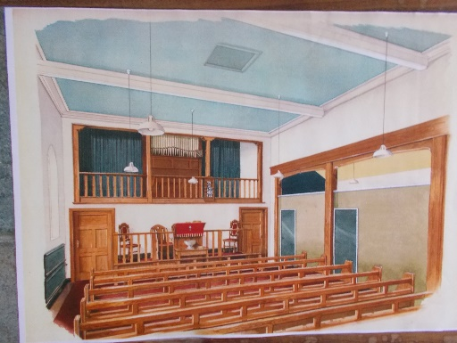
Fig. 36. Walpamur colour scheme for Central

At some date prior to the planning for a new church building, the Walpamur paint company, based in Darwen, was asked to design a colour scheme for the painting of the interior of Central. The scheme is shown in Fig. 36. It is not known whether it was utilised in the church

In the late 1950s/early 1960s Helsby Methodist Churches (Central, Avenue and Hapsford; see below for details of Avenue and Hapsford) put out a series of booklets giving church service times, and containing recipes and cooking and gardening hints, financed by 16 advertisements by local shops and businesses such as T. O’Hara (shoe repairs), R. Boow (dairyman), Parker’s butchers, Britannia Bakery. None of those 16 businesses still exists in 2022. No price was shown on the booklets, so presumably they were free. It is thought that the aim was to raise money from the 16 advertisements for the new church building fund, because in one booklet the amount in the building fund account was given as £4,520 18s 0d on 1 May 1962.

United Methodist Free Church Alvanley Mission

At some time in the late 19th century a Mission was set up in Alvanley House, on Alvanley Road. Its name suggests that it was an outreach (a ‘pulpit’) from Helsby United Methodist Free Church (Central), and not a church plant. Alvanley House is actually in Helsby, as the boundary between Helsby and Alvanley runs along Alvanley Drive. The earliest information found about the Mission is an item in the Cheshire Observer for 11 December 1897, and the latest an item in the Chester Chronicle for 17 July 1915:

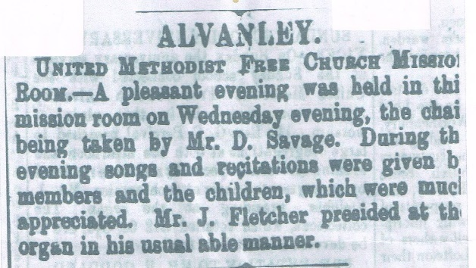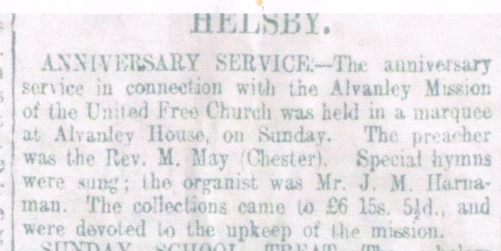
Fig. 37. Cheshire Observer 11.12.1897 Fig. 38. Chester Chronicle17.7.1915

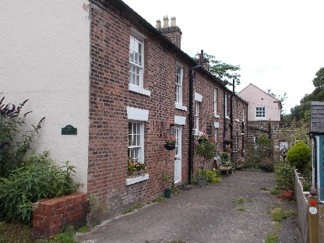
Fig. 39. Alvanley House
The Mission Room was a ground-floor room at the far end of Alvanley House. No documentation has been found about the Alvanley Mission. However, the diary of David Savage (the Mr. D. Savage mentioned in Fig. 37 above) shows that he was a registered Methodist lay preacher, who was registered in the 1881 census as a farmer of 50 acres living in Chester Road Helsby. His preaching covered a wide area, extending from the Mission church (presumably the Alvanley Mission Room) to Dunham Hill, Frodsham Free Church and The Hurst Kingsley. Also included on the plan were The Bourne Methodist Church, Frodsham, and Dutton Workhouse. Sunday Schools were held alternate months at Littler’s Farm on Bates Lane Helsby, Ainsworth’s farm on Marsh Lane Frodsham, and Netherton Hall farmhouse. His 1909 diary records: ‘Preached off a flat cart on the farm, only 200+ here today’. Another entry reads: ‘February 13th 1910, preached at Mission Church, theme was “David and Goliath”’.

One has to wonder why, with three Methodist churches in Helsby and several in Frodsham, some lay preachers still preached John Wesley-style in the open air, attracting large congregations.

Helsby Primitive Methodist Sunday School (Avenue)

Avenue Primitive Methodist Sunday School was opened in 1902, more than 40 years after Central opened. The exact date is not known. There is a foundation stone that reads: “This stone was laid by Mr. J.T. Atherton of Helsby…”, but unfortunately the rest of the stone is hidden by wooden decking.

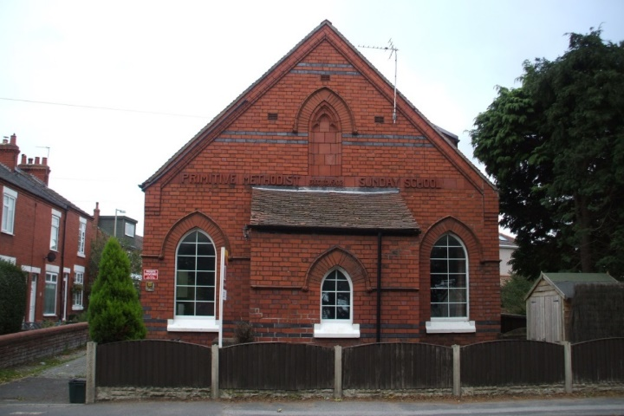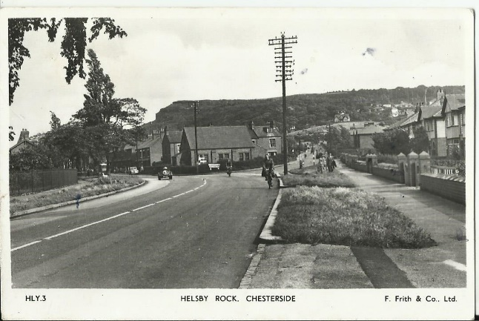
Fig. 40. A recent photograph of Avenue Sunday Fig. 41. Postcard view of Avenue Sunday
School School ca. 1955

However, the Frodsham & District Free Church Chronicle for February 1901 shows Helsby Primitive Methodists holding weekly services on Sundays at 2.30 and 6.30 pm and on Mondays at 7.00 pm. It also announced: ‘Free salvation proclaimed’. It is not known where they worshipped before Avenue was opened.

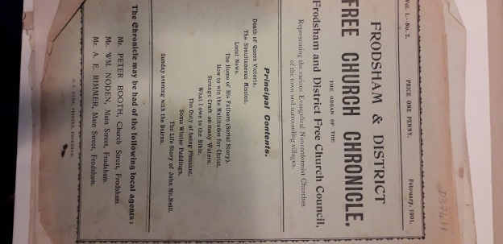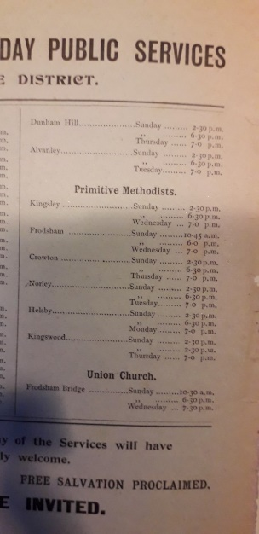

Fig. 42a and b. Frodsham & District Free Church Chronicle for February 1901

Why was there a need for a third Methodist church in Helsby? It is possible that the Primitives were seeking to extend their influence, but in that case why a Sunday School and not a church? The location of Avenue is perhaps a clue. The nearby BICC (British Insulated Callender’s Cables) company was expanding rapidly towards the end of the 19th century because of the increasing need for both rubber vehicle tyres and electrical equipment, with a consequent growth in the population of Helsby, and hence more children.

The company built several terraces: Cable Terrace (on the main road), Crosland Terrace and Back Crosland Terrace; the latter two were named after the joint founder of the company, George Crosland Taylor (Frodsham and District History Society Journal, Issue 51, December 2021). The company also built several large semi-detached houses on Robin Hood Lane for their managerial staff.

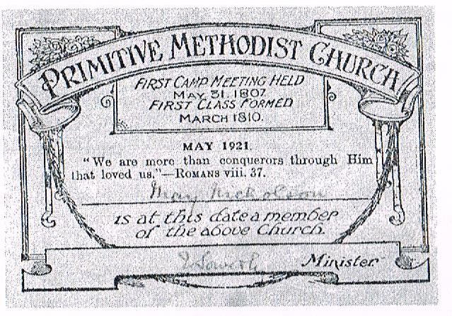
Fig. 43. Avenue Class Ticket, May 1921

Avenue Sunday School also held worship services, and was licensed for marriages (with a registrar present), so was also known as Avenue Church. Bob and Thelma Abel were married there. Fig. 43 below shows a Class Ticket for May Nicholson (Thelma’s mother) in May 1921. It was signed by the then minister, Rev. J. Sowerby.

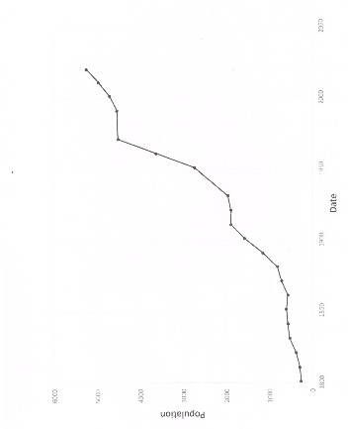
Fig. 44. Helsby population growth 1801-2020
Fig. 44 shows the growth in population of Helsby from 1801 to 2020. Banbury (1978) stated that the first reason for the growth in Helsby population was the quarry, with a number of houses being built for the quarrymen. The second reason was the coming of the Chester-Warrington railway in 1850 (see also Farish, 1889), followed by the line to Hooton in 1863. The third, of course, was the growth of the BICC factory.

The population growth in the period 1881-1911 was quite marked. The value for 2020 was estimated.

Cheshire Archives have a number of documents from Avenue Church. Below are a few snippets from minutes of Trustees’ (T) Annual Meetings and Leaders’ (L) Meetings:

1st December 1949 (L). Membership was 24. It was felt that a letter of reminder to some of our members as to the duties and privileges of membership might be an advantage.
2nd March 1950 (L). Some of the Avenue Church Youth Club members are also attending the Trinity Girls’ Club and the suggestion was made that next winter the two clubs should combine.
28th February 1952 (L). Details of the 50th Anniversary Services to be held on 6th and 7th April 1952 were again considered. The Monday meeting would be addressed by Rev. D. Irvine (a former minister) to be preceded by a public tea at 5.45 p.m.
4th February 1957 (L). The number of people in adult membership was 32.
5th May 1962 (T). Mr. Dearden had filled a pulpit appointment at short notice. He was not yet a member however.
7th September 1962 (T). Poor Stewards’ Report. The poor of the village should be helped if any cases of genuine hardship should arise.
4th December 1962 (L). Youth Club. There are at present some 60 young people attending and it is proposed to produce 2 plays, a comedy and a religious play, The Trial of Jimmy Brown. The club has recently suffered from an invasion of youths of an undesirable and aggressive type and on one occasion the police have unfortunately had to be called out to deal with them.

Avenue Church closed on 4 April 1965, and the congregation moved to Central, with the inaugural service at the new Central church being held on the following Sunday, 11 April.
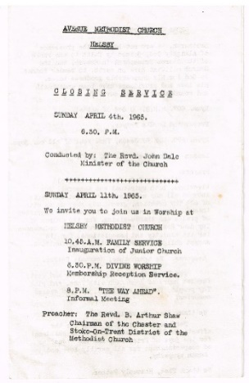

Fig. 45. Invitation to closing service at Avenue Church

Recent history of Helsby Methodist Church

In a letter printed in a booklet, Renewal, prepared for the opening of the new Methodist Church in April 1965, Rev. George Gibson, who was Helsby’s Methodist minister 1950-1955, wrote: ‘The opening of your New Church is the fulfilment of a vision…I think it would be true to say that the first steps were taken during my ministry among you when we were led to organise quarterly united services’.

In 2007 Helsby Hillside Women’s Institute published a booklet entitled Helsby Heritage. It included an article written in 1961 by Rev. Godfrey Kenyon, who was Helsby’s Methodist minister for the period 1955-62. The article contains much valuable first-hand information, and is reproduced here in full:

‘The present time is such an exciting one for the Methodist People in Helsby that I shall only very briefly deal with the distant past in order that I shall have space to write about the plans for the future. It is often forgotten that the first Church in Helsby was the former Wesleyan Church which stands next to the Parish Church. It is over a hundred years old and it is believed that prior to the erection of this building a small Methodist Society met in one of the cottages opposite the present building. Some years later the United Methodists opened a Church in the centre of the village which is now known as the Central Methodist Church but at that time was known as Zion Chapel. Later still, just over fifty years ago, the Primitive Methodist Church built a Sunday School, which was also used as a place of worship. This is now known as the Avenue Methodist Church.

‘In the year nineteen hundred and thirty two the then three Methodist Denominations joined together to form the Methodist Church. Within this area a circuit of churches was formed, composed of the three former denominations and ministers took up residences at Kingsley, Frodsham and Helsby. This, incidentally, was the first time that a Methodist Minister had been resident in the village and automatically had taken charge of the three Methodist Churches.’

It is appropriate at this point to mention the names of Helsby Methodist ministers from 1932 to 1955.

1932-1936 Rev. James Portman
1936-1939 Rev. William Collins
1939-1942 Rev. Frank Ridyard
1942-1946 Rev. Gordon Balderson
1946-1950 Rev. David Irvine
1950-1955 Rev. George Gibson

Prior to 1932 Helsby had no Methodist minister of its own, but was served from Frodsham. The following were Frodsham Wesleyan ministers prior to 1932, so would have taken services at Helsby’s Trinity Wesleyan Church.

Rev. Martin Jubb 1872-1874; Rev. John H. Rogers 1874-1877; Rev. Frederick Haines 1877-1880; Rev. John M. Bamford 1880-1883; Rev. George L. Allen 1883-1884; Rev. Edwin Mosscrop 1884-1887; Rev. John Shipham 1887-1890; Rev. Patrick Pizey 1890-1893; Rev. Robert Renton 1893-1896; Rev. J. Richard Hargreaves 1896-1899; Rev. Thomas H. Bailey 1899-1902; Rev. Edwin Gelder1902-1905; Rev. William H. Moseley 1905-1908; Rev. J. Leonard White 1908-1911; Rev. William Stevenson 1911-1915; Rev. Thomas Barron 1915-1919; Rev. Charles E. Norman 1919-1925; Rev. Arthur Gray 1925-1929; Rev. George W. Reece 1929-1935.

Rev. Kenyon’s article continued: ‘It is not always easy for Churches which have lived independently of one another to join together overnight and, therefore, from 1932 to the present time there has been a process of growing together. In January 1954, the Manpower Commission of the Methodist Church, which is a body which considers the question of redundant Churches, suggested that ‘steps be taken to reduce the number of Societies (Methodist Churches) in Helsby’. No action was taken on this suggestion. In 1955, however, this paragraph appeared in the minutes of a meeting of the Trustees of the Avenue, Central, and Trinity Methodist Churches: “It was suggested that in the not too distant future it might be found practicable to close the three present places of worship and erect a new modern church in the village with up to date amenities. It was a possibility which should be given due thought and consideration”.

‘This was the beginning of a new era in the life of the Methodist people in Helsby. Later that same year (1955) at a meeting of the leaders and trustees of the three Methodist churches the following extract appeared in the minutes. “A proposal was introduced that a committee be formed to investigate the possibilities of building a new Church in Helsby. After discussion it was unanimously agreed that the following people form a committee to investigate the building of a new Church: Rev. R. Waugh (Superintendent Minister 1953-58), Rev. G Kenyon, Messrs. P. Tittle, H.S. Mumby, A. Lea, A. Boardman, E.B. Davies, A. Dunn.”

‘This has been largely responsible for shepherding this scheme through its many stages. One of the first things that this committee had to do was to find a site for the new church. We discovered that the field next to the Central Church would shortly be coming on the market but we were not expecting that within that same week we should be called upon to make a decision upon the matter. Within three days we had called a meeting at which over £1,000 was promised in loans, which in turn meant that the field was ours. I am more than convinced that we received the guidance of God at this very critical stage in our venture. Since that time so much has happened. The architects, Paterson and Macaulay of Bebington have drawn up the plans for a new Church, which will cost over £14,000. It is to be a modern building which will accommodate two hundred people.

‘May I at this point pay tribute to the wonderful spirit shown by the members of the former Trinity Methodist Church, Helsby, who agreed to amalgamate with the Central Methodist Church as a first step to re-uniting the Methodist Churches in Helsby. It is never easy to say goodbye to your spiritual home but the way in which it was done in this case shows a conviction that the future for Methodism in Helsby is even more promising than in the past.

‘One last thing. How is the money for this project being raised? We need to raise half the amount of the cost of building the church. £7,000 is a lot of money to raise but I am pleased to report that we are raising over a thousand pounds a year very largely in the form of donated gifts from the people of Helsby. We hope to have £5,000 in the Building Fund by the end of the fourth year of the opening of the Fund.

‘This achievement speaks for itself. It is the result of people having a vision and then getting down to the hard business of making it come true. Perhaps it may be summed up in the words of Joseph Hart.
“We’ll praise Him for all that is past,
And trust Him for all that’s to come.”
‘The original purchase of land was made possible by the interest-free loans from members of our Church.’

A Young Wives group was formed in 1961, which met fortnightly, often with invited speakers. The name was changed to the Ladies’ Evening Group (LEG) in 1970; it is still running at the time of writing (2022). Their 50th anniversary was celebrated on 12 October 2011.
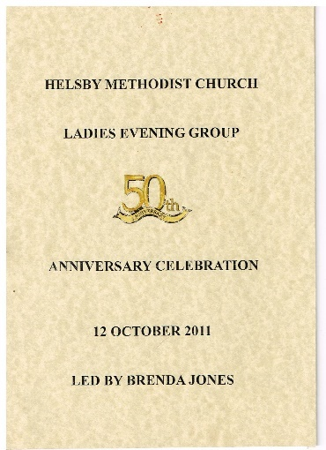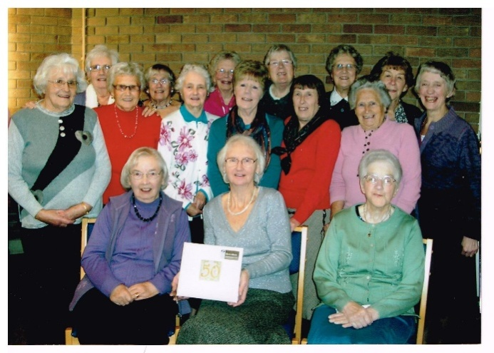

Fig. 46. LEG 50th anniversary leaflet Fig. 47. LEG members at 50th anniversary

In 1961-62 extensions to provide a kitchen and toilets were built. ‘A rather exceptional amount of voluntary work, earth moving, digging drainage trenches, woodwork, painting and decorating, wiring, etc., etc. was carried out by the men folk of both Central and Avenue Churches…A number of the ladies of both Churches have provided refreshments on the site during working operations…The working party have done a magnificent job in completing the first stage of the scheme, the next step will be the construction of the front retaining wall and main entrance, and finally, the building of “OUR” New Church.’

A Building Fund Financial Report issued by the church in 1963 showed that by April 1963 the Building Fund stood at £5382-3s-10d.

A letter to our then minister, Rev. John Dale, from the architects, Paterson and Macaulay of Bebington, dated 23 March 1964, gave six tenders for the building of the new church:

Frank Warburton & Son, Warrington £15,661
Ainsworth & Garner Ltd., Runcorn £15,864
Henry Jones & Son £16,005
Frank Berry & Son Ltd. £16,183
Harry Fairclough Ltd. £16,880
Mohim Bebington Ltd. £16,926

It is not known whether these prices included the building of the manse.

Ainsworth & Garner were appointed to build the church. The Joseph Rank Benevolent Trust gave £5,000, and the Methodist Church Chapel Department gave £1,000.

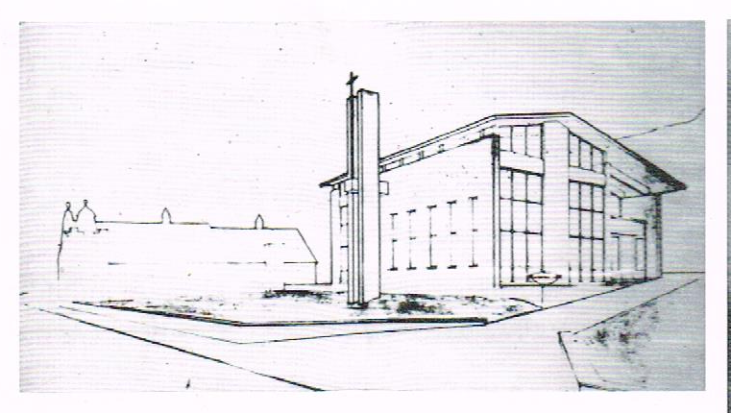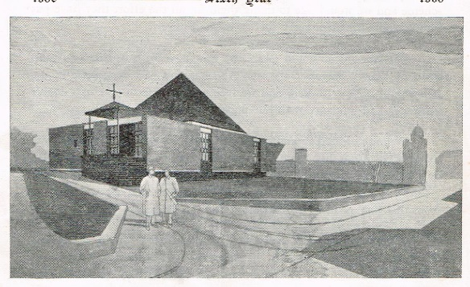

Fig. 48 (a) and (b). Two artists’ impressions of the proposed new church. The first one is similar in shape to the former Dunham Hill Methodist Church (see Fig. 99).

The new manse was built before the new church. Up until that time the manse was no. 18 Chester Road, Helsby.

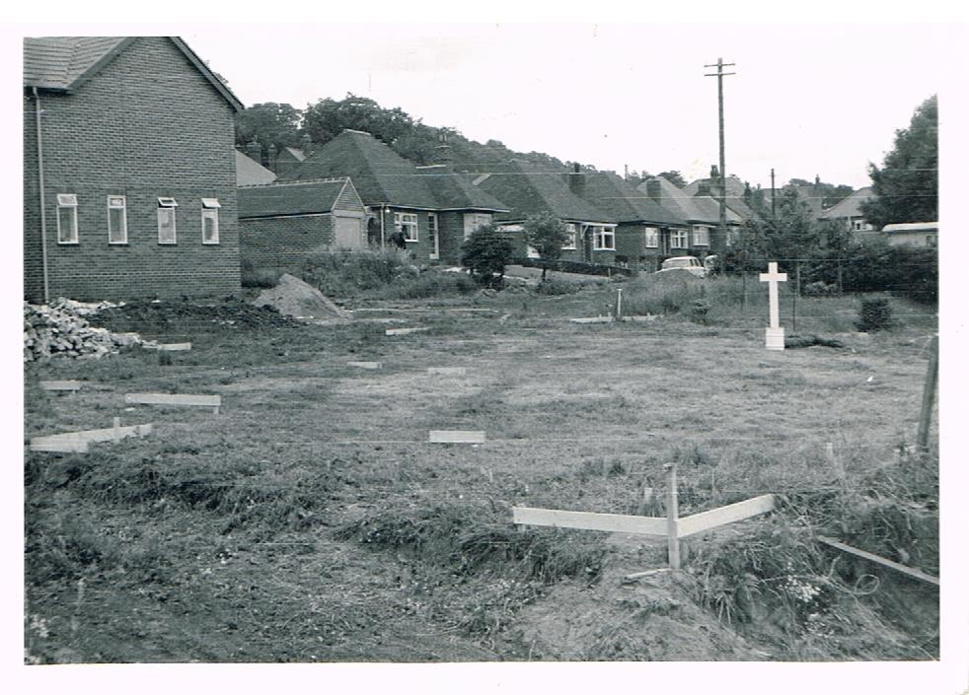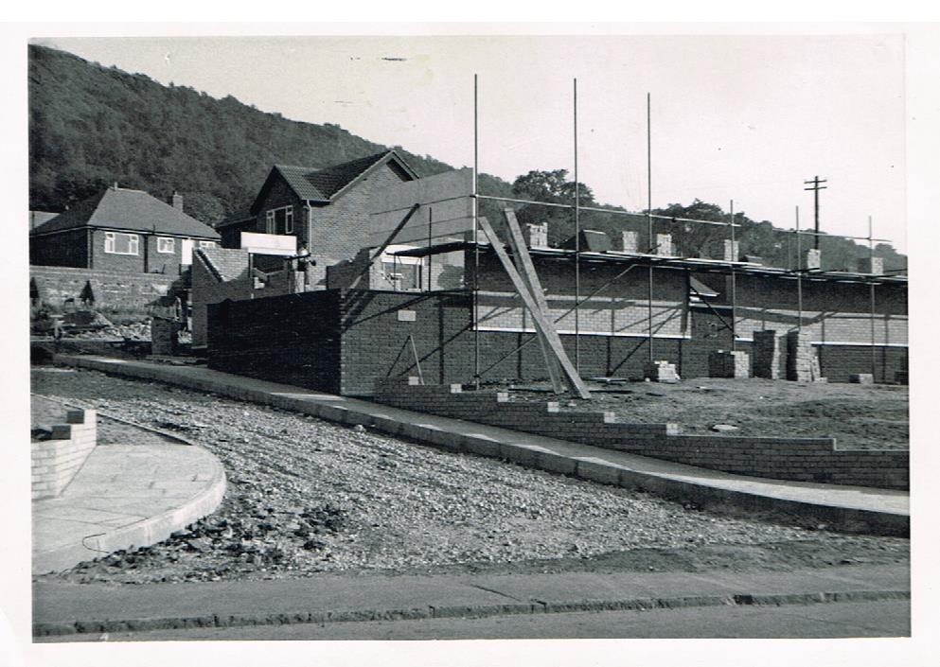

Fig. 49. Manse and site for church Fig. 50. Church under construction

The manse was officially opened on Saturday 29 August 1964 by Herbert Spencer Mumby (Circuit Steward 1949-61) at a thanksgiving service led by Rev. Vernon C. Cowell, the then Superintendent Minister of the Frodsham Circuit. Note the one shilling charge for the programme!

The stone-laying and dedication ceremony for the new church was held on Saturday 19 September 1964, with the stone being laid by Sir Harold Woolley CBE, a former president of the National Farmers’ Union, and later Lord (Baron) Woolley of Hatton. The photograph below (Fig. 53) shows him holding the silver trowel used in the ceremony.

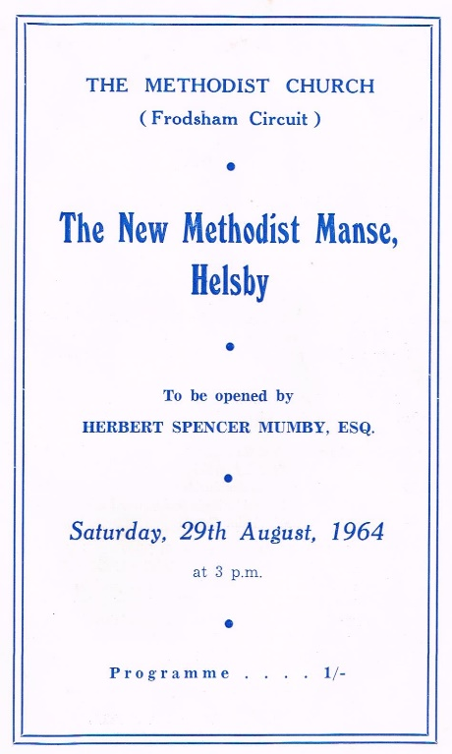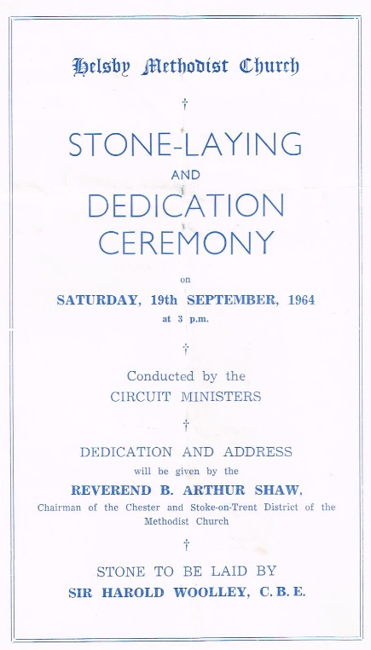
Fig. 51. Manse opening ceremony Fig.52. Church stone-laying ceremony

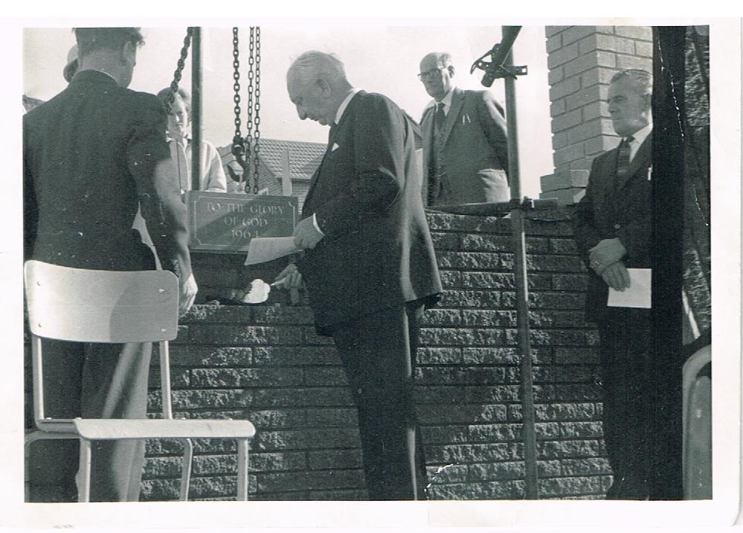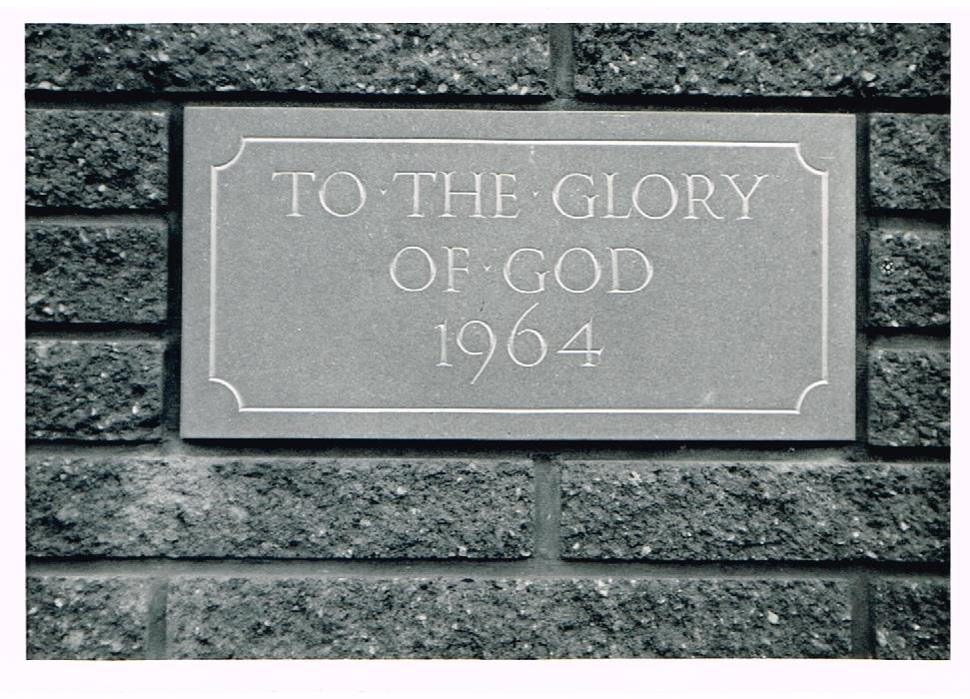

Fig. 53. Sir Harold Woolley laying the stone Fig. 54. The stone, inset into the wall of the
steps up to the then main entrance of the church

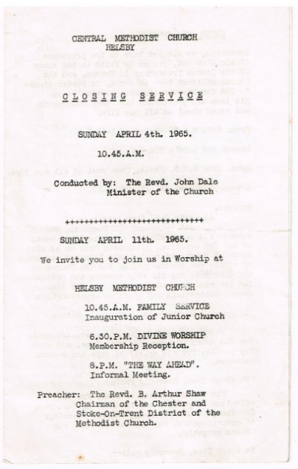

Fig. 55. Closing service at Central

The opening service for the new Helsby Methodist Church (HMC) was held on the following Saturday, 10 April 1965.

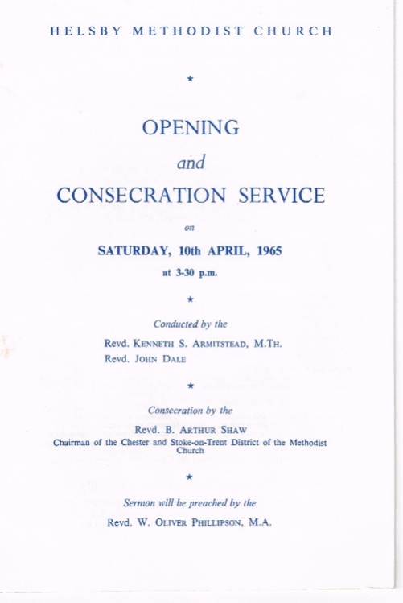

Fig. 56. Opening service for HMC

A Cradle Roll was set up in 1965, and Andrew Abel, son of Bob and Thelma Abel, was the first name listed, having been christened on 6 January 1965. A mid-week fellowship in the church hall ran on alternate Wednesdays, from the 1960s to the 1980s; a wide range of topics were discussed, with many meetings having an outside speaker.

It is appropriate at this point to give the names of HMC ministers from 1955 onwards. They were:

1955-1962 Rev. Godfrey Kenyon 1962-1965 Rev. John Dale
1965-1971 Rev. Kenneth Lane 1971-1978 Rev. William Jones
1978-1984 Rev. Keith Davies 1984-1985 Rev. Philip Webb
1985-1988 Rev. Thomas Read 1988-1991 Pastor Mark Sleet
1991-1992 Rev. Brian Kirkpatrick (Int)* 1992-1999 Rev. Andrew Baguley
1999-2003 Rev. Ashley Cooper 2003-2007 Rev. Nicholas Holt
2007-2016 Rev. Stephen Santry 2016-2017 Rev. Christine Jones (Int)
2017-2022 Rev. David Bintliff 2022-? Rev. Alison Crookes

*Interregnum

Below are photographs of those ministers.
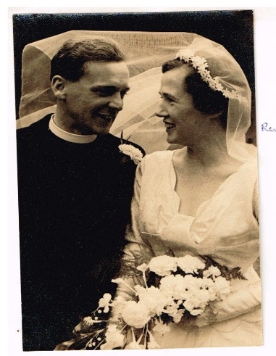
Fig. 57. Rev. Godfrey &Valmai
Kenyon (1955-1962). Their
wedding date is not known

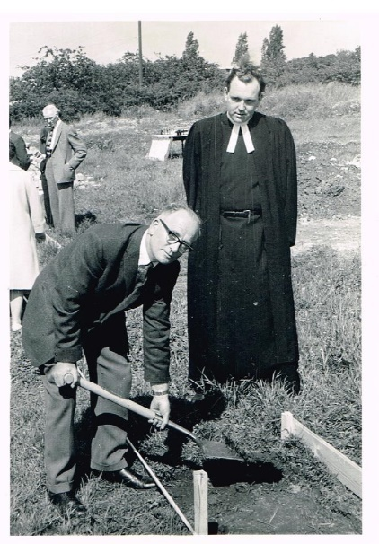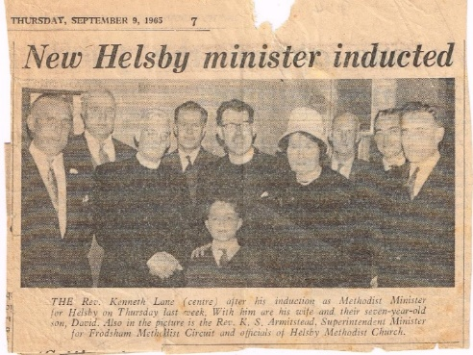

Fig. 58. Rev. John Dale (1962-1965) Fig. 59. Rev. Kenneth Lane (1965-1971) and
& Mr. Percy Tittle, church treasurer, his wife at his induction service on Thursday
at the turf-cutting ceremony for the 2 September 1965
new church on Saturday 20 June 1964
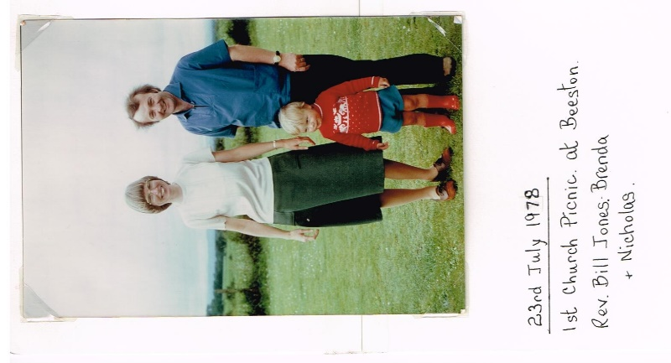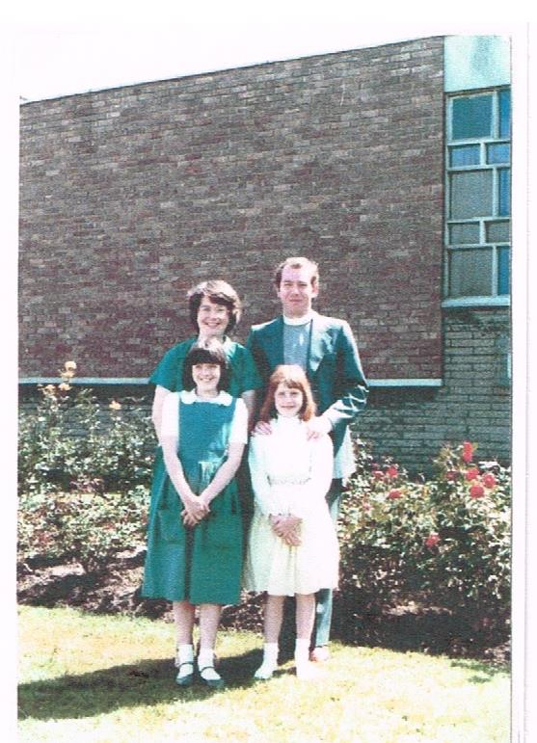
Fig. 60. Rev. William (Bill) Jones, his Fig. 61. Rev. Keith Davies, his wife Sylvia
wife Brenda and son Nicholas and daughters Joanna and Sarah
(1971-1978) (1978-1984)
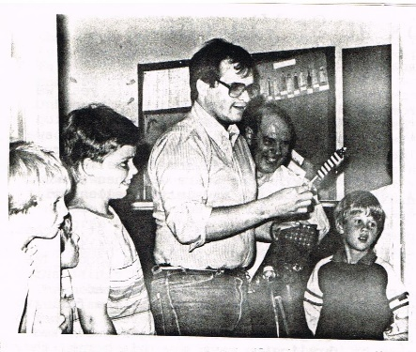
Fig. 62. Rev. Philip (Phil) Webb (1984-1985)

Phil Webb was a student at the Perkins School of Theology in the Southern Methodist University in Dallas, Texas. He applied to come to the U.K. as part of his training, and was seconded to the British Methodist Connexion for one year. He has some English roots, as his grandfather came from a Derbyshire village, Edingdale. His parents lived in Iowa Falls, Iowa; his father and elder brother were also Methodist ministers. Phil wrote in the Autumn 1984 issue of Crosstalk: ‘As I write this, I have been in the circuit for ten days. I have experienced (and continue to experience from time to time) culture shock. The people here have overwhelmed me with care, concern and warmth. This has indeed made me feel welcome and at home, and for this I thank you.’

As Phil was a bachelor, he was inundated with baked goods by the ladies of the church. It is rumoured that he returned to the U.S.A. rather heavier than when he arrived.

Whilst he was here, Phil had the sad task of visiting a former member, Mrs. Emily Rogers, whose daughter Enid had been murdered by her boyfriend on the afternoon that HMC held its 1964 Christmas Fair. Mrs. Rogers later gave the marble font which sits on the altar table, in memory of her daughter.

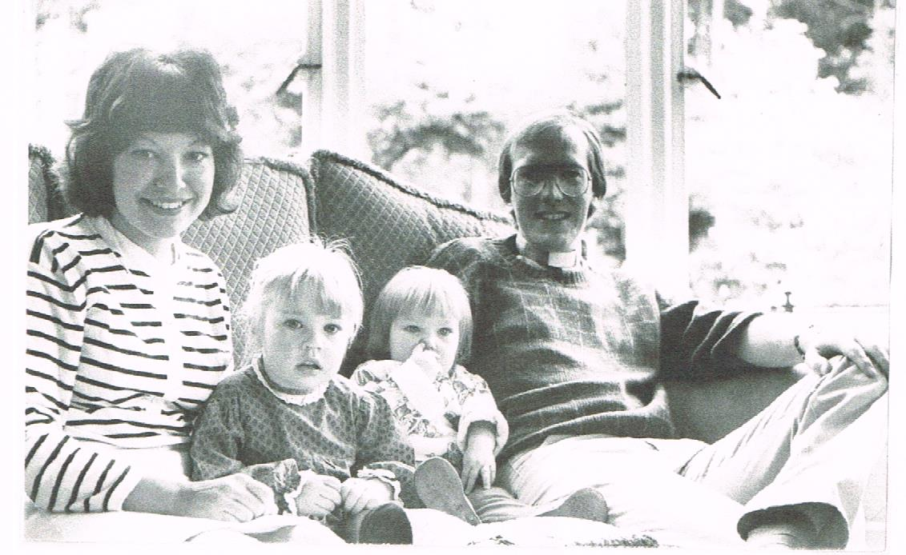

Fig. 63. Rev. Thomas (Tom) Read, his wife Jane and
daughters Rebecca and Charlotte (1985-1988)

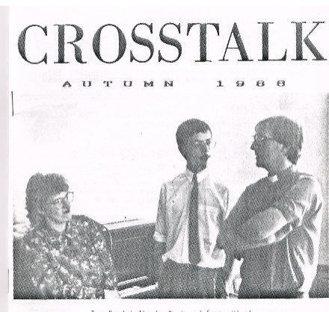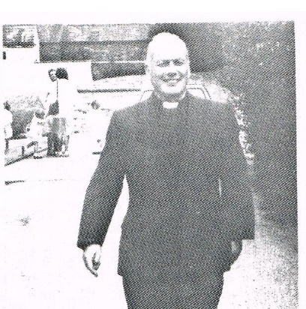

Fig. 64. Karen & Mark Sleet (1988-1991) Fig. 65. Rev. Brian Kirkpatrick, who
with Rev. Tom Read was our presbyter during Mark Sleet’s
time as our pastor, and was our
minister in 1991-1992

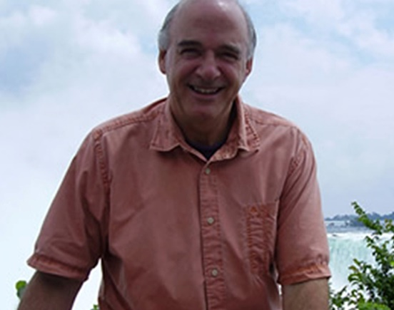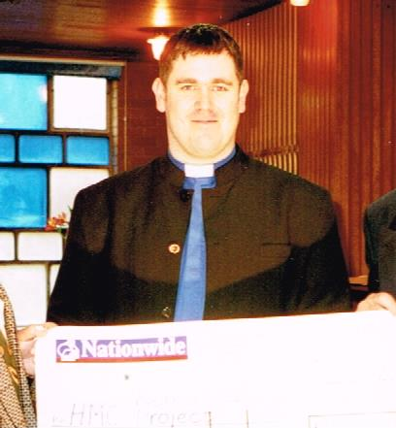

Fig. 66. Rev. Andrew Baguley (1992-1999) Fig. 67. Rev. Ashley Cooper (1999-
2003)

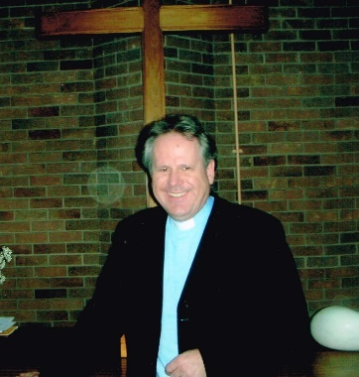

Fig. 68. Rev. Nicholas (Nick) Holt (2003-2007)

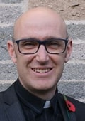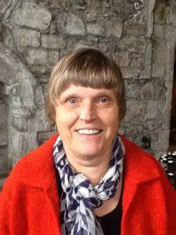

Fig. 69. Rev. Stephen (Steve) Fig. 70. Rev. Christine Jones
Santry (2007-2016) (2016-2017)

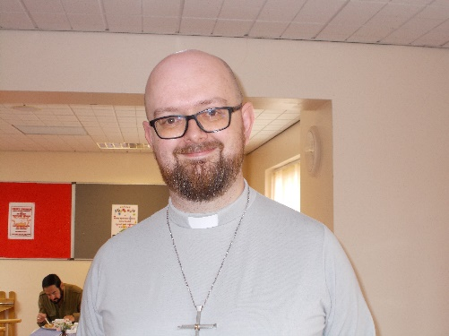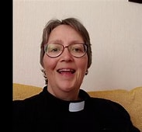

Fig. 71.Rev. David Bintliff Fig. 72. Rev. Alison Crookes
(2017-2022) (2022-?)

The opening of our new church building in 1965 was a step (albeit a very big one) in the continuing development of HMC. In 1975 it was decided to extend the Sunday School premises in the lower hall. Almost all of this work was done in-house from February 1975 to September 1976, with Mr. Alec Boardman in overall charge. The total hours worked were an astonishing 3861½, involving 35 men, women and teenagers. Unsurprisingly Alec Boardman clocked up the most hours (573½), with Arthur Webb not far behind on 508½ hours.

The Opening and Dedication service was held on Saturday 18 September 1976.

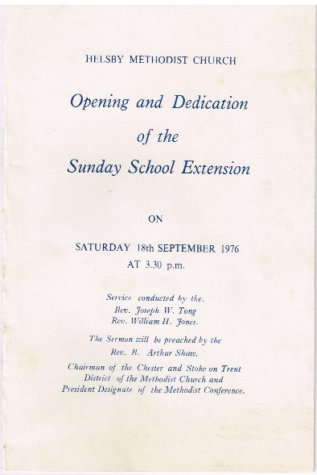

Fig. 73. Opening of Sunday School extension

In May 1973 Helsby Methodist Church, St. Mary Magdalene Roman Catholic Church (a ‘tin church’ opened in 1961 and closed in 1978, located at the top of Rake Lane, on the site now occupied by four detached houses – ‘The Heights’) and St. Paul’s Anglican Church put on a Three Churches Festival as part of the Call to the North. The Call to the North came in 1969 from the Archbishop of York, the Roman Catholic Archbishop of Liverpool, and the Moderator of the Free Church Federal Council to present the claims of the Christian faith to all the parishes of the ’Northern Province’. The Festival ran from 13 to 20 May 1973.

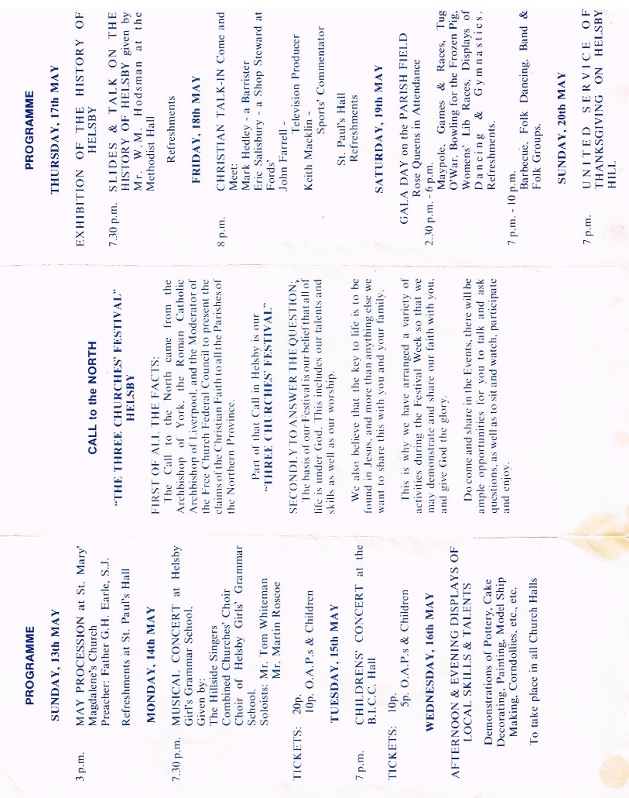

Fig. 74. Helsby Three Churches Festival May 1973
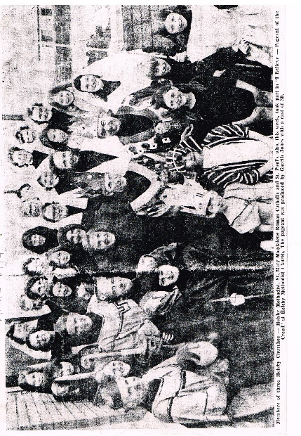
Fig. 75. Cast of ‘I Believe – Pageant of the Creed’ 1974
In April 1974 the same three churches put on a presentation at HMC called ‘I Believe – Pageant of the Creed’ It was produced by Gareth Jones with a cast of 30.

A similar event, ‘To Travel Hopefully’, was performed in 1976.

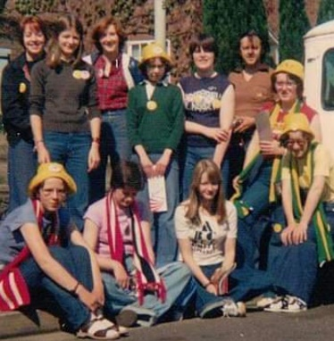
Fig. 76. HMC Youth Fellowship, ca. 1977
The Youth Fellowship was well attended in the 1970s and 1980s. Fig. 76 shows them in about 1977.

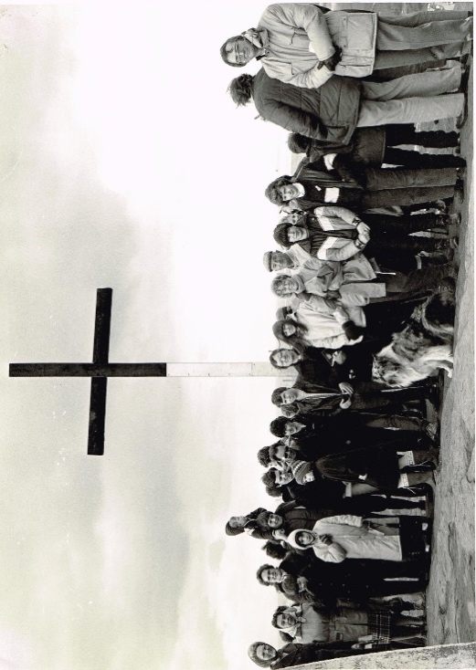
Fig. 77. Walk of Witness, Helsby Hill, ca. 1978
Easter has long provided an opportunity for a joint service and Walk of Witness on Good Friday. When congregations were younger and fitter the Walk included the ascent of Helsby Hill, where a large wooden cross had been erected by men from St. Paul’s Church. Fig. 77 shows the walkers at the top of the hill, probably around 1978. The bottom half of the cross was sheathed in metal to prevent its being damaged or chopped down, which sadly had happened in some previous years.

During Rev. Keith Davies’ ministry in Helsby several house groups were started in members’ homes, and some are still running.

Starting in the 1970s, a number of church ‘family weekends away’ were organised. The first was at Pontin’s Holiday Camp in Prestatyn, probably in 1977 or 1978, followed by one at a Christian Endeavour property in Kents Bank (near Grange-over-Sands), probably in 1982. The next was at Plas-y-Coed, a Methodist Guild Holidays property in Colwyn Bay, in 1983, then Willersley Castle (another Methodist Guild property) near Matlock in Derbyshire, in 1984 (see Fig. 78 below).

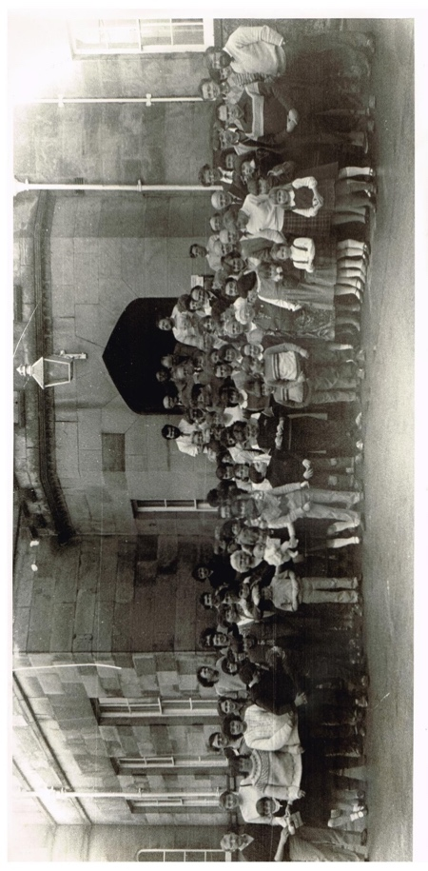
Fig. 78. HMC at Willersley Castle in 1984
Willersley Castle was again the venue in 1986, 1988 and 2000. Three weekends away were held at Kinmel Hall, near Abergele in North Wales (1985, 1987 and 1989), and one at the Palm Court Hotel in Blackpool in 1993. The last one was held at another Methodist Guild property, Abbott Hall, Kents Bank, in 2003. N.B. Methodist Guild Holidays later became Christian Guild Holidays; it was wound up in January 2022, following losses because of the Covid-19 pandemic.

One of Rev. Billy Graham’s Mission England crusades was held at Anfield, Liverpool F.C.’s ground, on 14-21 July 1984. HMC arranged for a coach to go from Helsby to Anfield every evening, and every house in Helsby was leafleted to encourage people to go. A number of HMC members offered ministry to those who went forward to make a commitment.

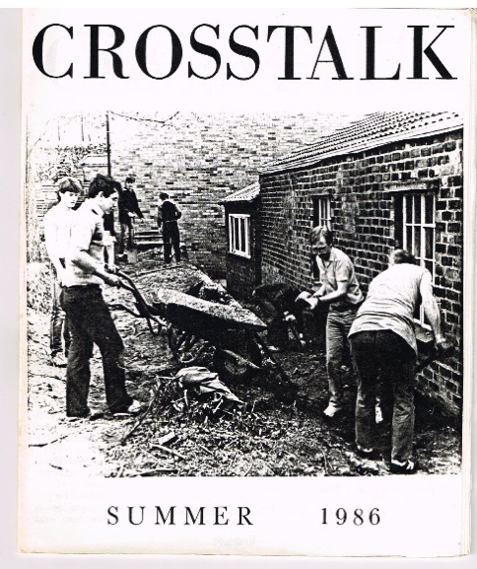
Fig. 79. Working to re-lay path, 1985
In 1986 dry rot was found in the floorboards and floor joists of the lower hall, caused in part at least by the path outside having been laid higher than the damp-proof course. The path was re-laid (see Fig. 79), but the whole floor of the lower hall had to be taken up.

It was also decided the raise the floor level of the former church part of the lower hall by 14 inches to that of the former Sunday School to provide a large level area. All of this work was very expensive. A special service in May 1986 was held to launch the appeal to raise funds. Fifty-seven families pledged a total of £10,566 to be given over the next two years. Further to the pledges, a number of people covenanted their gifts, which meant that income tax on those gifts would be refunded. Grants from outside bodies were also sought. An article in the Summer 1987 issue of Crosstalk detailed the huge amount of work that had been done, and all that still remained to be done. It is not known whether there was a celebration ceremony or service to mark the completion of the work.
For many years church members sang carols in several areas of Helsby, collecting money for the National Children’s Home (now Action for Children). In at least one year carols were sung and mince pies were offered outside the then National Westminster Bank (see Fig. 80).
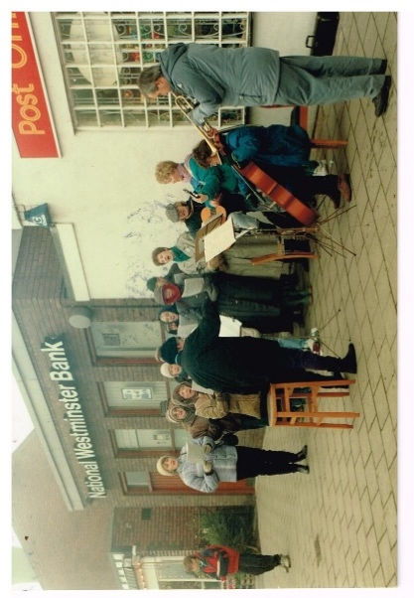
Fig. 80. Carol singing and mince pies

The photograph was taken in either 1988,1989 or 1990, as Mark Sleet’s wife Karen was present. A number of passers-by were reluctant to accept a mince pie, thinking perhaps that they would be asked for a donation.

HMC and Frodsham Methodist Church put on Roger Jones’s musical From Pharaoh to Freedom at HMC as the Sunday evening service on 7 May 1989. It is not known whether the musical was also performed at Frodsham.

In 1990 the church celebrated the 25th anniversary of the opening of the new church. Pastor Mark Sleet led both morning and evening services on 8 April. In the afternoon there was an organised non-strenuous walk and a cycle ride, and five homes (those of Ted & Norma Clare, George & Mabel Coulter, Phil & Flora-Nell Duke, Marshall & Joan Penney and Ian & Joy Watson) offered ‘open-house’ visits.

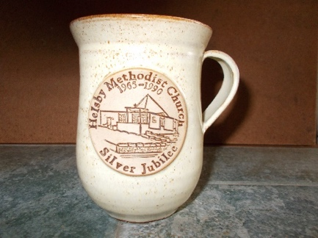

Fig. 81. Commemorative mug for 25th anniversary of our new church

The Women’s Fellowship Group was formed in 1943, when Rev. Gordon Balderson was our minister. They celebrated their 50th anniversary on 25 October 1993.

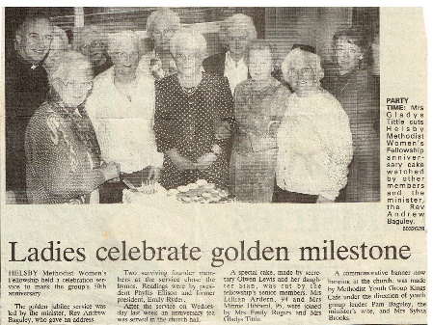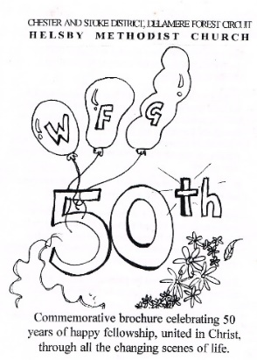

Fig. 82 a and b. Women’s Fellowship Group 50th anniversary celebration

The WFG ceased to meet after 15 April 2015, because of falling numbers.

Despite all the extensions and improvements to HMC premises over many years, the 1965 church was still physically separate from the Sunday School and former church buildings, so that people had to go outside to reach one from the other. Consideration of how to link the building began in the 1990s. In addition, new legislation regarding disabled access and facilities, and health and safety, meant that significant improvements were necessary.
Different levels in the two areas meant that a complex scheme had to be prepared and executed. In addition, the interior of the sanctuary had to be re-orientated through 90°, from facing approximately south-west to approximately south-east, to allow access from the linking premises; the sanctuary was fitted with double-glazed windows, a new office was built, and the whole site was re-wired.
Paterson, Macauley and Owen were appointed as architects, having also been architects for the new church building opened in 1965. Over several years the scope of the project grew, and a final plan was agreed by the Connexion in March 2002. The cost of the project also grew, to £313,600. The church had over £70,000 in the Circuit Advance Fund, and raised more money by holding three gift days. In addition a significant grant was obtained from WREN (Waste Recycling Environmental Ltd.), and part of the church land was sold to the environmental company RSK for £80,000 for use as a car-park. (RSK actually found other land in Priestner Drive for car parking, and sold the land that they had bought from the church, on which two houses were then built.)
The church also obtained small grants from the District and the Connexion, and obtained some money from the Circuit Advance Fund. Work started in 2004, and the new linking premises were dedicated on Saturday 4 February 2006 by the then President of the Methodist Conference, Rev. Tom Stuckey.

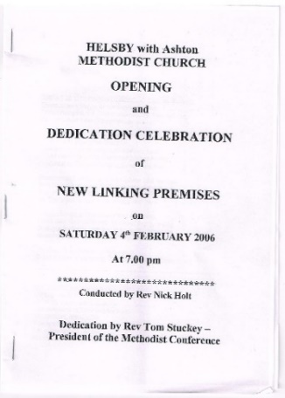

Fig. 83. Celebration of opening of new
linking premises on 4 February 2006

Re-development of the lower hall kitchen was completed in 2009, and in 2016-17 the lower hall was refurbished, including a new roof, flooring and heating.

The 1980s. 1990s and 2000s saw much mission and outreach activity at HMC. Children’s and youth work covered a broad range, including Finger-post (which ran from 1985 to 1995 after Sunday School) and Pathfinders. Crosstalk for Spring 2003 reported: Friday Fun Club, Junior Church, schools work, Parent & Toddler Group (later called Muddles, then Stay & Play), Chips@TheManse, Youth Night (in The Room at 184 Chester Road), and Open the Book school assemblies.

In 1999 HMC, together with Methodist churches in Altrincham and Stoke-on-Trent, began an outreach, under the ægis of an organisation called Aid for Children – North West Action Group (chaired by our then minister, Rev. Ashley Cooper) to children hospitalised with AIDS in Constanta, Romania, a port city on the Black Sea with a population of almost 700,000. The Action Group committed to providing and fitting a new kitchen and dining room at the hospital/hospice in June 2000, estimated to cost £15,000, and to providing an outside playground. Two teams were sent, including a number of people from HMC, led by Ashley Cooper and Geof Robinson. In 2001 four teams were sent, one co-led by Rev. Keith Davies, our minister from 1978 to1984. Work done included electrical work, tiling and decorating, and on the morgue. By the end of 2001 the hospice was completed.

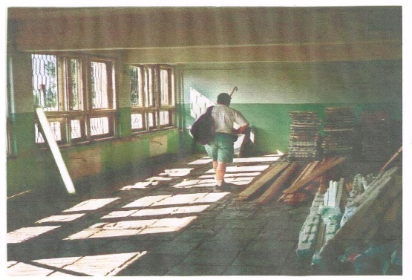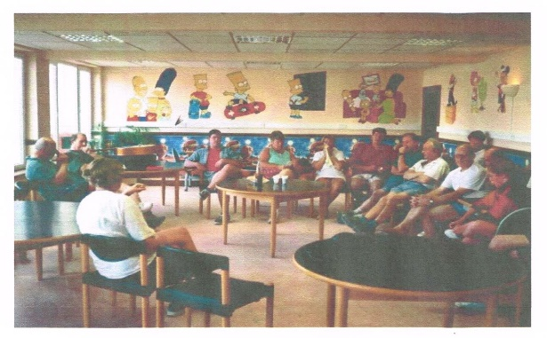

Fig. 84. Dining room before renovation Fig. 85. Dining room after renovation

In 2000 Chris Weller organised a variety concert at HMC in aid of the Romania project, which raised over £250.

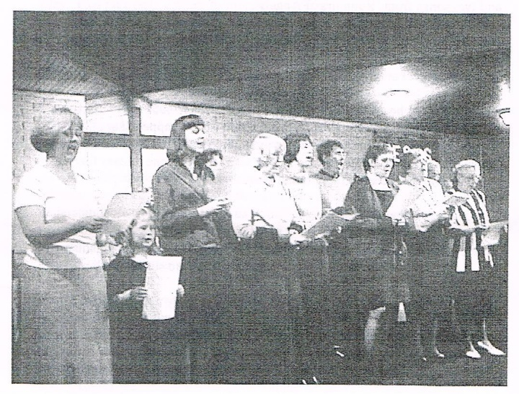

Fig. 86. The choir at the Romania aid concert

In 2002 the same group of Methodist churches formed a new charity, STEPS Romania (Shelter, Training, Education, Purpose, Street children), which worked with a Romanian charity, Association Fairplay, whose aim was to provide shelter and hope for street children. The objectives were to renovate and equip a hostel, improve living conditions there, and help and train individual children, meeting their needs. Conditions in the hostel were horrendous, and there was no glass in many of the windows. After 2005, Geof Robinson continued going out to Romania each year (sometimes accompanied by his wife Viv) until 2018.

The Room
No. 184 Chester Road used to be a pharmacy, owned and run by Mr. Edwin Davies, as well as a home. The actual pharmacy was in the front of the house, accessed from the main road. In 1999 the present owner, Rachel Barnett, offered the use of the pharmacy room to HMC as a café outreach, to be called The Room; this required the installation of kitchen equipment and seating. It was run by HMC volunteers, and was open several days a week – a place where people in our village could come for a cup of tea or coffee and a chat.

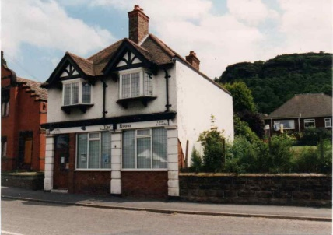

Fig. 87. The Room

The former Vale Royal Borough Council also became involved, and used part of The Room for a ‘People Net’ project, which enabled people to learn the basics of computing. Later TRAIDCRAFT goods were available, and also a range of second-hand books. The Room was also used in the evenings for youth work, led by the then lay worker Linda McDowall. The café closed after a few years because of low usage, although the youth work continued for some years more.

Alpha courses
From the mid-1990s HMC gained a reputation as a place of training, resourcing, encouragement and empowering. This was achieved primarily though our Alpha courses, Holy Spirit days and conferences, which regularly attracted several hundred delegates from churches of all denominations. Additionally the church put on evenings of celebration and ministry and live@HMC events at other churches throughout the north-west of England and beyond.

Our first Alpha course was held in 1994, and our last was in 2009. We also ran many Alpha Holy Spirit days from 1997 to 2009 for people from other churches, because many churches found such days difficult to put on.

Conferences at HMC

1996 Times of refreshing
1997 Soar with the Spirit
1998 Holy and anointed
1999 Learning to minister in the power of the Spirit
2000 Called and equipped
2001 Breaking the chains – releasing the Church
2002 Encountering God
2003 Kingdom living

HMC was also involved with national Alpha conferences:

Cheshire Alpha Conference, held at HMC, October 1997
Scottish Alpha Conference, held at Motherwell, April 1998
Methodist Alpha Conference, held at Cliff College, November 1999

Easter People

When Rev. Rob Frost first put forward a proposal to start Easter People, it was turned down by every single Methodist committee he approached – something that was perceived as being too radical, too risky, and would never work! Frustrated, upset and despondent, Rob shared this with a friend who prayed for him and believed that if this was of God it would happen and told him to go back and face the committees again. Amazingly each committee voted unanimously in favour of the event – God had answered his prayer and opened the door to an exciting new venture, the objective being an event for all ages with a time of teaching, celebration, fellowship and fun. The first Easter People was held at Camber Sands, near Rye, in 1988, then moved to various other locations (e.g. Bournemouth, Llandudno, Scarborough), and finally to Blackpool in 2007. A number of people from HMC attended many of these events, and found them powerful and uplifting.

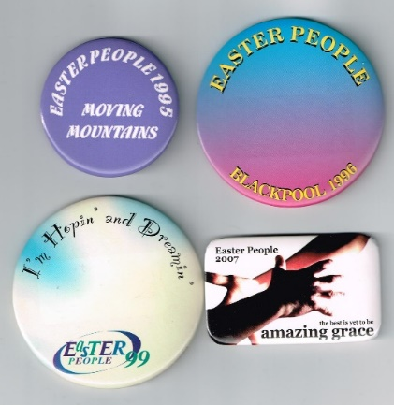

Fig. 88. Some Easter People badges

Following the demise of Easter People, one of our former ministers, Rev. Ashley Cooper, inaugurated a similar Easter event, ECG (Equipping, Calling, Going) in 2008 at Llandudno. It moved to Scarborough in 2012.

During Rev. Cooper’s time here, HMC together with several other churches put on three Christian musicals. The first was Prince of Egypt, which was performed at Frodsham Community Centre and at Easter People in 2001. The following year Godspell was performed at Ellesmere Port Civic Hall and at Easter People (Fig. 88), and in 2003 Jesus Christ Superstar was performed at Frodsham Community Centre, Wesley Methodist Church (Chester) and at Easter People.

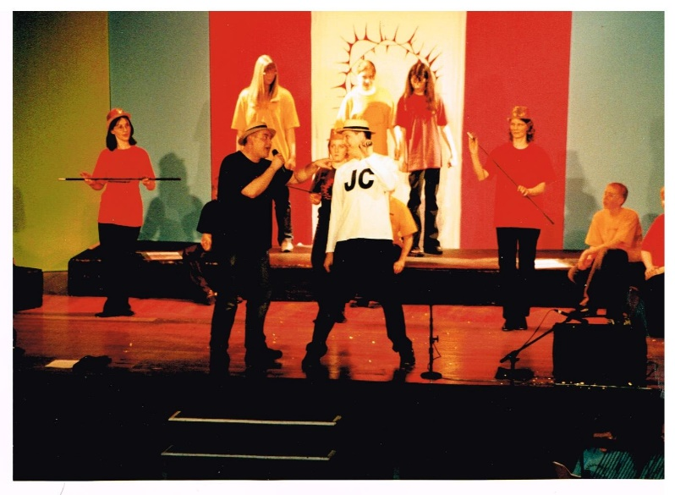
Fig. 89. Rev. Ashley Cooper and Ian Oulton singing in Godspell

Fig. 90 below shows HMC members and attendees in 2011. Rev. Steve Santry can be seen at the back, by the window.

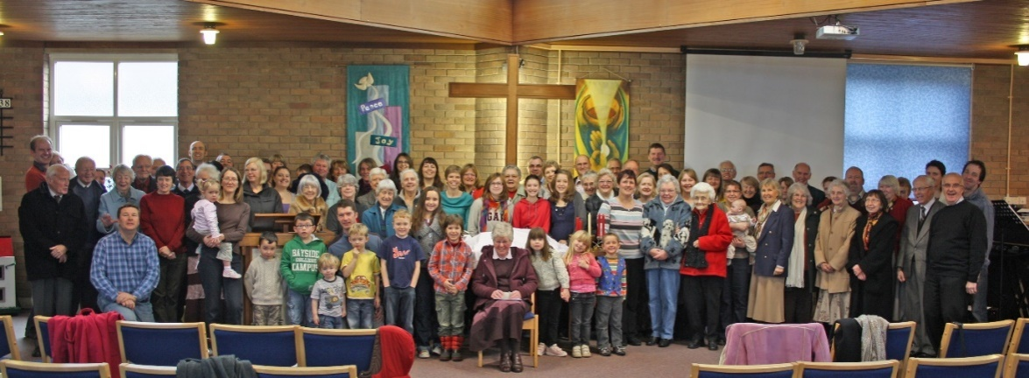

Fig. 90. HMC in 2011

Hope Journey

Hope Journey (https://thehopejourney.org.uk) started in 2008 at Hope Farm Methodist Church in Ellesmere Port to support the delivery of some areas of the RE (religious education) syllabus in schools. Through the efforts of our then Children’s and Family lay worker, Cath Clarke, we put on a Hope Journey called ‘Remembering World War 2’ at HMC for Helsby primary schoolchildren in 2017 and 2018, and in 2019 we put on ‘Sharing Parables’ at Horn’s Mill Primary School.

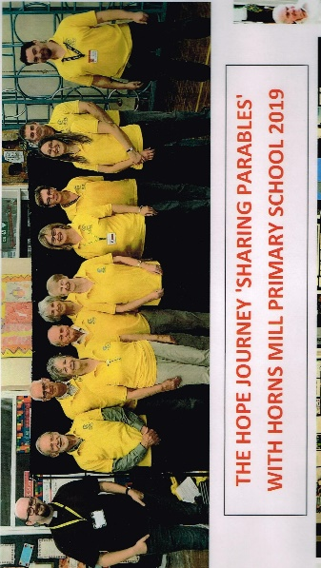

Fig. 91. ‘Sharing Parables’ at Horn’s Mill School in 2019

Covid-19 Pandemic

Because of the Covid-19 pandemic HMC, like all U.K. churches, had to close from March to September 2020. However, because of the IT skills of our then minister Rev. David Bintliff and our music leader Simon Chesterson we were able to deliver Sunday services online, and these continued after HMC reopened. Initially those attending church had to answer a series of questions (Fig. 92) and sign in as an aid to Track and Trace should someone attending be found to have Covid.. Hands had to treated with sterilising gel, masks had to be worn, no singing was allowed, and chairs were spaced 2 metres apart: the preacher and the musicians stood behind Perspex screens.
Churches had to close again in January 2021, and reopened at Easter that year. Gradually these restrictions were lifted, until services were back to normal by early 2022. Services also continued online, as it was found that many more people were attending online (including some from other areas and even from abroad) than normally attended in person.

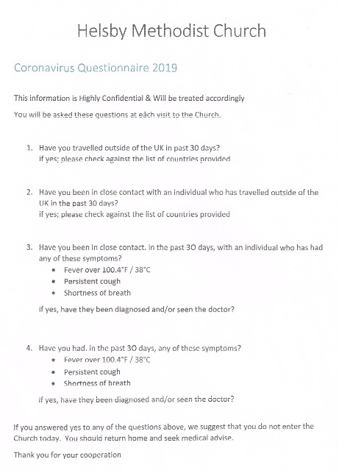

Fig. 92. Covid-19 questionnaire

Other local Methodist churches

Ashton Primitive Methodist Church

Ashton opened in 1845 and was rebuilt in 1888 so as to be more commodious. The laying of several foundation stones for the re-building of the chapel in October 1888 was recorded in the December 1888 Primitive Methodist Magazine; the foundation stones are still there (see Fig. 94). From September 2003 it ceased to exist as a separate body and became a class of Helsby with Ashton Methodist Church. The 125th anniversary since the rebuilding in 1888 was held in July 2013. The church closed on 31 August 2013, and the building was then taken over by the Plymouth Brethren, who used it for some years. It was then converted into a private dwelling.

In 1851 there was an Ecclesiastical Census, during which data from all churches were requested. The return from Ashton Church is shown below (Fig. 93). On Sunday 10 March 1851 there was a congregation of 20 adults and 30 Sunday Scholars in the morning, and of 72 adults in the evening.

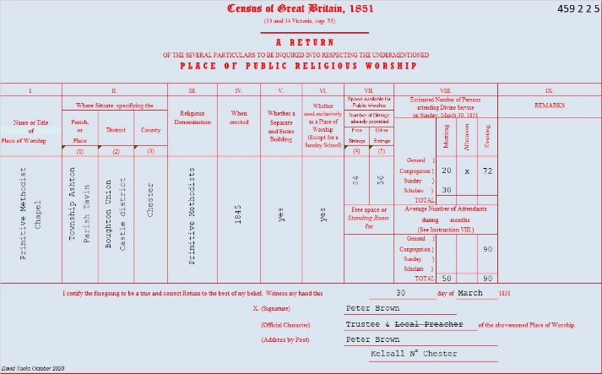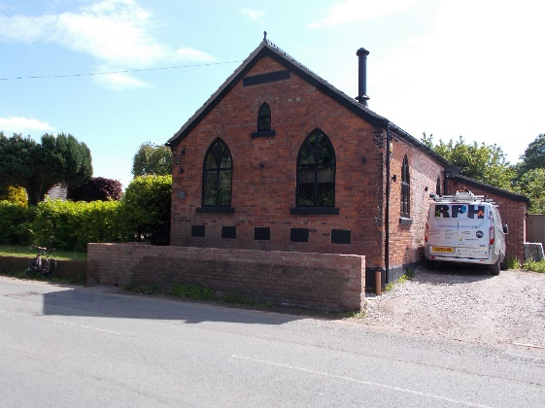

Fig. 93. 1851 Ecclesiastical Census return for Fig. 94. The former Ashton Primitive
Ashton Church Methodist Church. The plaque just under
the gable reads:
METHODIST
CHURCH 1988

which suggests that the word ‘PRIMITIVE’ has been plastered over.

Hapsford Methodist Church

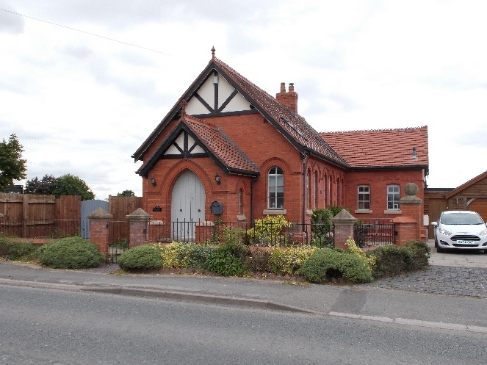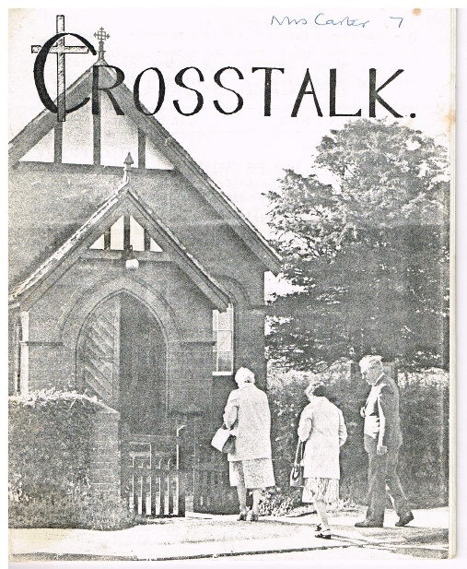

Fig. 95. The former Hapsford Methodist Church Fig. 96. Evening service at Hapsford, on
the cover of the Autumn 1984 issue of Crosstalk. The man is thought to be Henry Moss, who played the harmonium at services there.

The Chester Chronicle reported on 9 October 1897 that the new (Hapsford) Chapel and Sunday School in connection with the United Methodist Free Church was opened on 7 October 1897. ‘Services were formerly held in a room at the Station and at Hapsford Hall.’ The words ‘in connection with the United Methodist Free Church’ imply that Hapsford Chapel was built as an outreach or church plant from Helsby, since the only United Methodist Free Church in the area is the one in Helsby.

The chapel closed in 1995. In the Autumn 1995 issue of Crosstalk Henry Moss explained the reasons for its closure: ‘The findings of the Quinquennial Inspection have been alarming, the Chapel is in need of urgent repairs which would be very costly. There are other things to consider:- the Chapel is on a busy main road with no parking, toilets, water or kitchen facilities and few young people. As there seemed no alternative the decision was taken and the Chapel closed at the end of August.’ The ‘urgent repairs’ are believed to relate to dry rot.

Mouldsworth Wesleyan Methodist Church

Mouldsworth Methodist Church, in Chapel Lane, Mouldsworth, opened in 1816, and was rebuilt in 1877. The Sunday School (the section with the facing gable end in Fig. 97) was added in 1916. The church closed in 1995.

There is no record of any collaboration between Helsby and Mouldsworth Methodist churches. Marshall and Joan Penney were married at this church. No 1851 Ecclesiastical Census records could be found for this church.

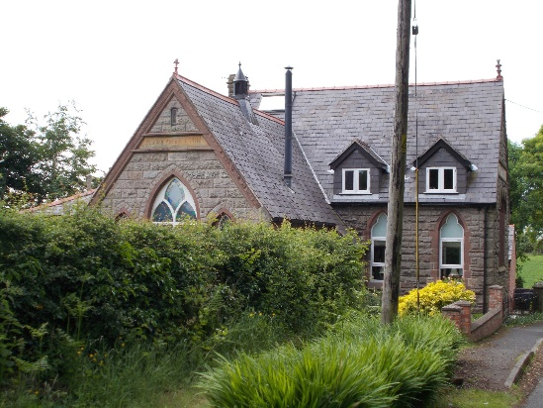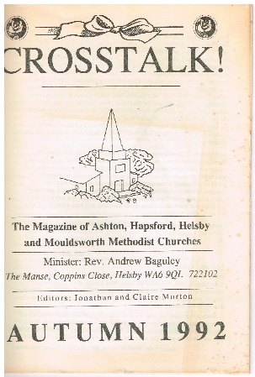

Fig. 97. The former Mouldsworth Fig. 98. Crosstalk! The magazine of Ashton,
Wesleyan Methodist Church Hapsford, Helsby and Mouldsworth Methodist Churches

Although HMC had never, so far as is known, had any contact with Mouldsworth Methodist
Church, the Autumn 1992 edition of Crosstalk stated: ‘Remember that Crosstalk is the
Magazine of Helsby and Hapsford Methodist Churches and now also of Ashton and
Mouldsworth – so “Hello” to all the new readers and new contributors”. Sadly the contact
with Mouldsworth did not last long, as it closed in 1995.

Dunham Hill Wesleyan Methodist Church

The Chester Courant for 22 June 1830 reported that there was a Sabbath School of 100 children in Dunham Hill, which was probably Methodist. Dunham Hill Methodist Church, in the Chester Circuit, opened in 1843, and closed in about 1972. It is now a private dwelling. The pebbledash building on the right, Chapel House, was the manse.

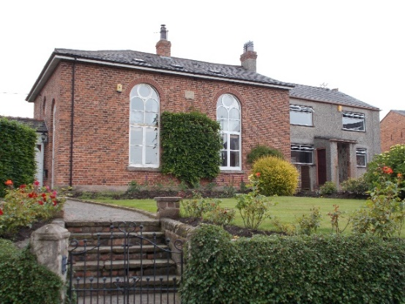

Fig. 99. The former Dunham Hill Wesleyan Methodist Chapel

The plaque reads:
WESLEYAN
METHODISTS
Chapel
AD MDCCCXLIII

The use of the plural is unusual, perhaps even unique. No 1851 Ecclesiastical Census records could be found for this church.

The Frodsham & District Free Church Chronicle for July 1901 reported that the Dunham Hill Methodist Sunday School anniversary would be held on 28 July. At a Circuit Quarterly Meeting held at Dunham Hill in July 1901, the same magazine reported that: ‘At the close the members of the Quarterly Meeting and their wives and other friends were sumptuously entertained at a knife and fork tea by Mr. and Mrs. Thomas Jeffs at their residence, Hapsford Hall’.

Manley Primitive Methodist Church

Manley Primitive Methodist Chapel in the Chester circuit was opened on 2 October 1859. The new chapel was designed in the Gothic style, seated 130 and cost £180 of which the members expected to raise half. J. Wright of Alvanley Hall gave the land. The chapel lies where Station Road becomes Tarvin Road, opposite the junction with Moss Lane.

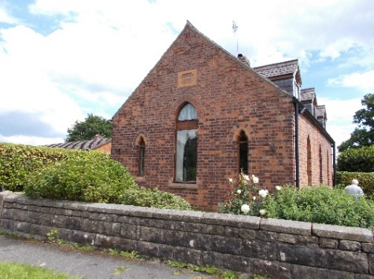

Fig. 100. The former Manley Primitive
Methodist Church

The church closed in 1970. So far as is known it remained empty for years, until it was sold in 2000 and converted to a private dwelling. The plaque on the gable end now has only the date 1859 on it.

It should be noted that both Dunham Hill and Manley Methodist Churches were in the Chester Circuit, and so had no contact with Helsby Methodist Church, which was in the Frodsham Circuit.

It is salutary that all five Methodist churches in villages close to Helsby are now closed and have become private dwellings. All but one of Frodsham’s Methodist churches have also now closed.

Bibliography

Bagshaw S., History, Gazetteer, and Directory of the County Palatine of Chester, Sheffield, 1850: https://specialcollections.le.ac.uk/digital/collection/p16445coll4/id/278553/.
Banbury L.G., A History of Cablemaking at Helsby Factory, 1978.
Bretherton, Francis Fletcher, Early Methodism in and Around Chester 1749-1812, Phillipson & Golder, Chester, 1903.
Challoner, Eric, It So Happened; from Plough to Pulpit, Fairway Folio, Alsager, 1998.
Farish W., The Autobiography of William Farish, 1889.
Janion J., Some Account of the Introduction of Methodism into the City, and Some Parts of the County, of Chester; Evans & Son, Chester, 1833.
Latham, Frank A. (Editor), Delamere: The History of a Cheshire Village, published by The Local History Group, printed by Herald Printers, Whitchurch, 1991.
Morris, Jean M, Across the Gap, Springfield-Farrihy Publishing, 2016.
Slater, George, Chronicles Lives and Religion in Cheshire and Elsewhere, Andrew Crombie, London, 1891.

Acknowledgments

I am grateful to the following people and organisations for providing me with much of the material for this document: John Anderson, Jane Arnold, Rachel Barnett, John Bell, Rev. David Bintliff, Roger Brooks, Simon Chesterson, Rev. Ashley Cooper, Moira Cooper, Christine Critchley, David Critchley, Jon Ford, Dr. Kath Gee, Edgar Gregory, Catherine Holden, Colin Holden, Denise Kidd, Nicola Lightfoot, Steve Lightfoot, Ross Nichols, Heather Oulton, Ian Oulton, Pippa Randles, Geof Robinson, Dr. Philip Rowe, Heather Rowland, Bill Smith, Dr. Peter Vardy, Rob Wigmore, Cheshire Records Office, Englesea Brook Museum of Primitive Methodism, Frodsham and District Local History Society, and especially Susan Lorimer, without whose enormous contributions and help I could not have written this History of Helsby Methodist Church.

All newspaper images prior to 1916 are © The British Library Board, with all rights reserved. I am grateful to The British Newspaper Archive (www.britishnewspaperarchive.co.uk) for permission to publish those images.

Note: I have endeavoured to be as accurate as possible with all the information provided in this History of Helsby Methodist Church. However, I have had to rely on many other documents for most of that information, and almost certainly there would have been some errors in some of those documents. One glaring example that I found was a document giving Rev. John Wesley’s date of birth as 1738, instead of 1703; 1738 was the year in which he felt his heart ‘strangely warmed’. Dates of newspaper items are almost certainly correct, but dates such as closure dates of chapels and churches may not be so accurate, as they tend not to be recorded.

